COMPILER DESIGN LAB
BCSE UG-3 (2022-2026)
GROUP: A3

MEMBERS:
NAME | ROLL NO.
DEBJIT DHAR: | 002210501106
SOHAM LAHIRI: | 002210501107
SUDIPTA SAHA: | 002210501124
CHIRANTAN NATH: | 101910501064

Project - 5

TABLE OF CONTENTS

CONTENTS | PG NO.
Problem Statement | 3
Flow Diagram | 4-7
Code | 8-29
Grammar Information | 30-64
Explanation | 65-82
Output | 83-86
Acknowledgement | 87

Problem Statement: Consider a simple Python-like language with
Data Type: integer (int) and floating point (float), string (str), boolean (bool) and list (list)
Data type of a variable is determined at the time of assignment of a value to it.
Python “for” loops are supported which loop over strings and lists.
The following statements are supported: assignment statements and ‘print’ statements. The statements may have arithmetic expressions with operators
‘+’, ‘--‘, ‘*’, ‘/’.
Part I – Construct a CFG for this language.
Part II – Write a lexical analyser to scan the stream of characters from a program written in the above language and generate stream of tokens.
Part III – Maintain a symbol table with appropriate data structures.
Part IV – Write a bottom-up parser for this language (modules include Item-set construction, computation of FOLLOW, parsing table construction and parsing).

System Description:
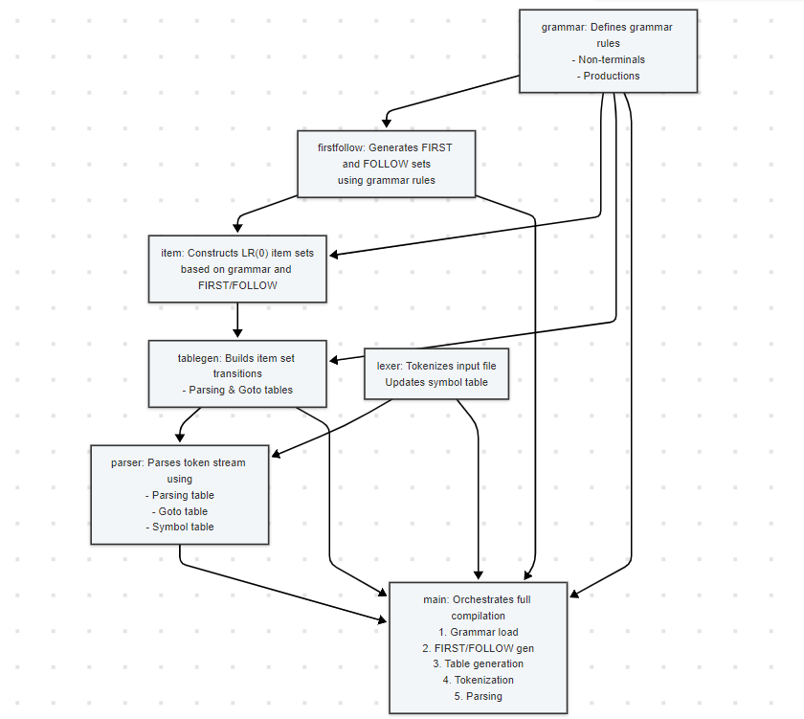Lexer Flow Diagram:
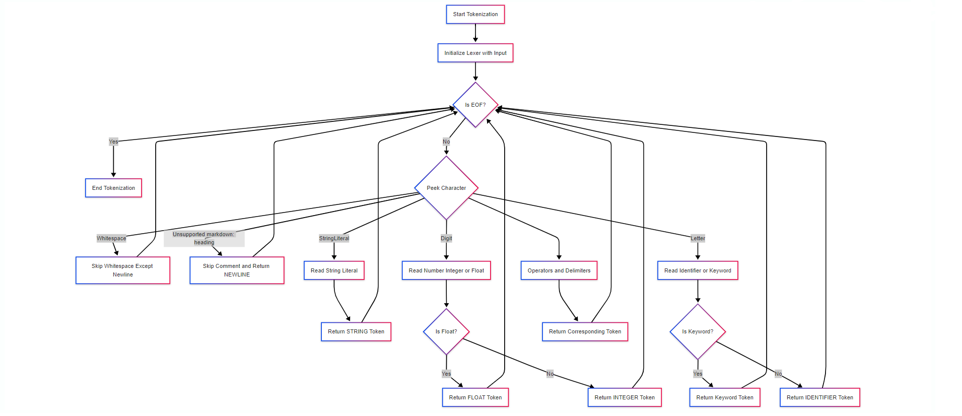

Lexer Class Diagram
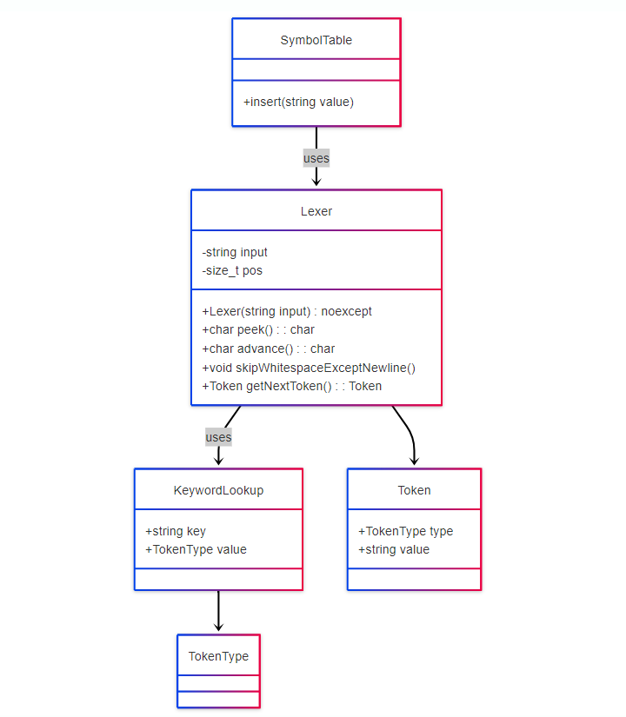
Lexer Metholodgy:
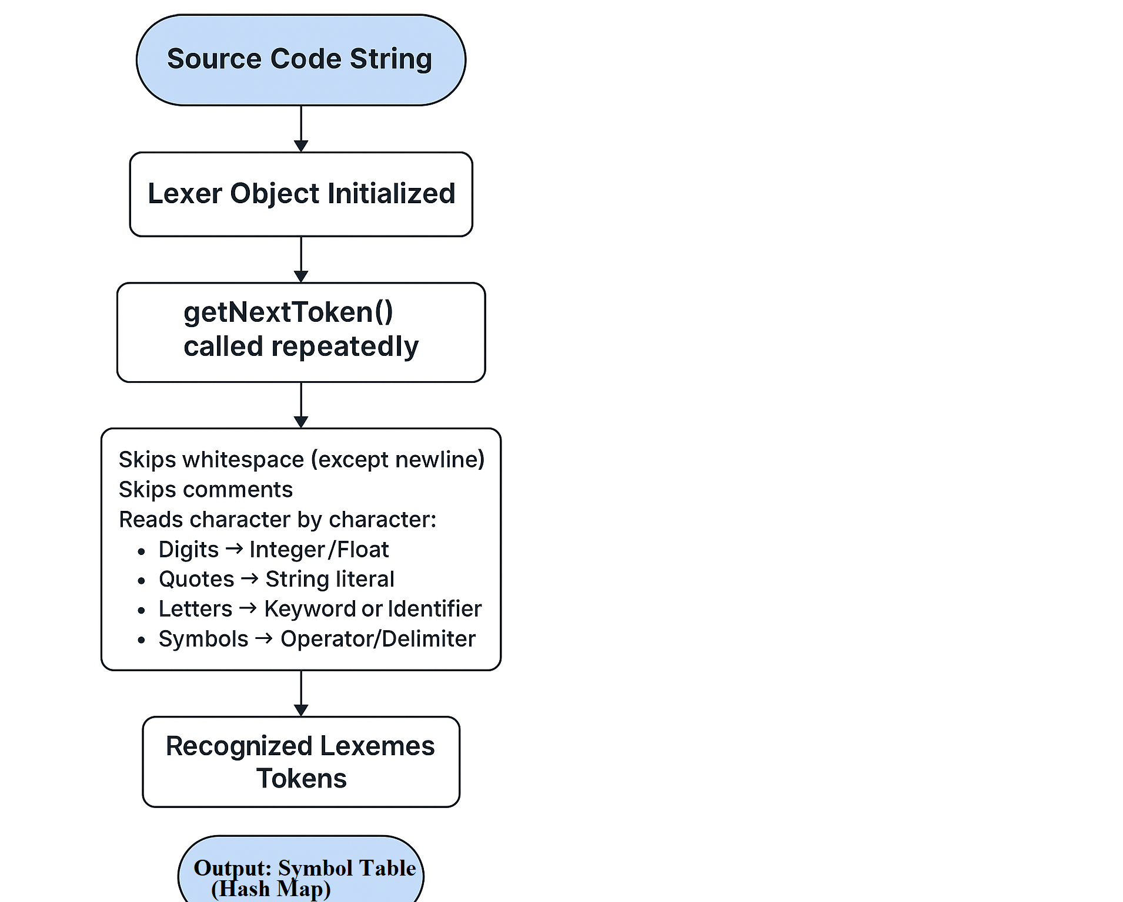
Parsing Flow Diagram:
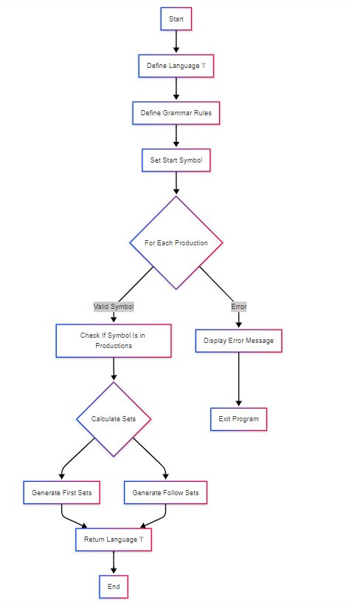
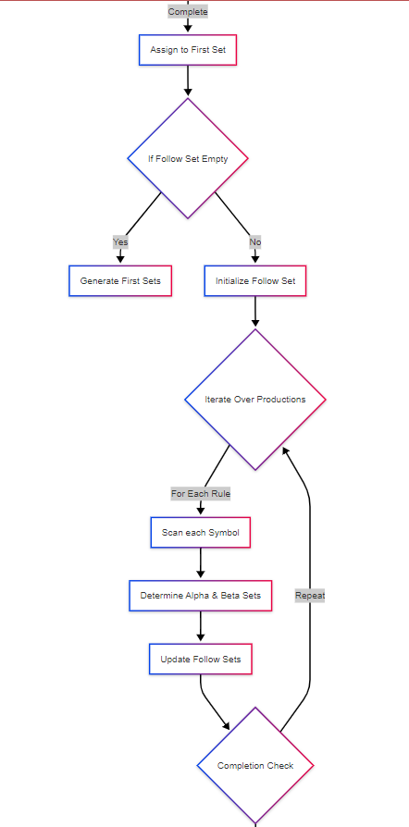
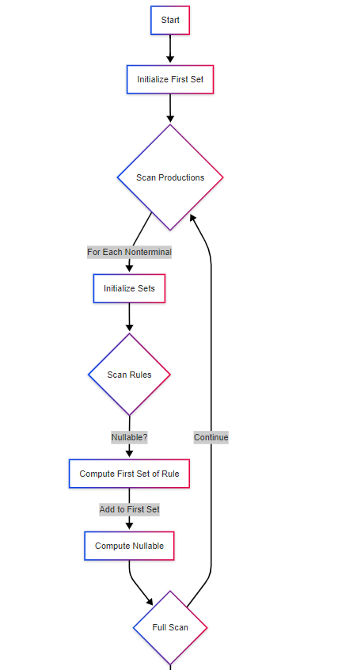
First-Follow Flow Diagram:

Item Set Flow Diagram:

Item Set Flow Diagram

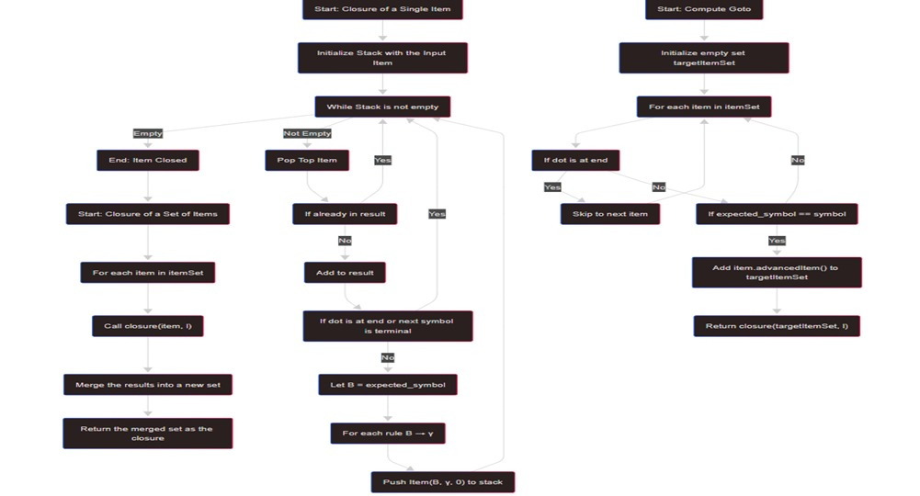

Parsing Flow Diagram:
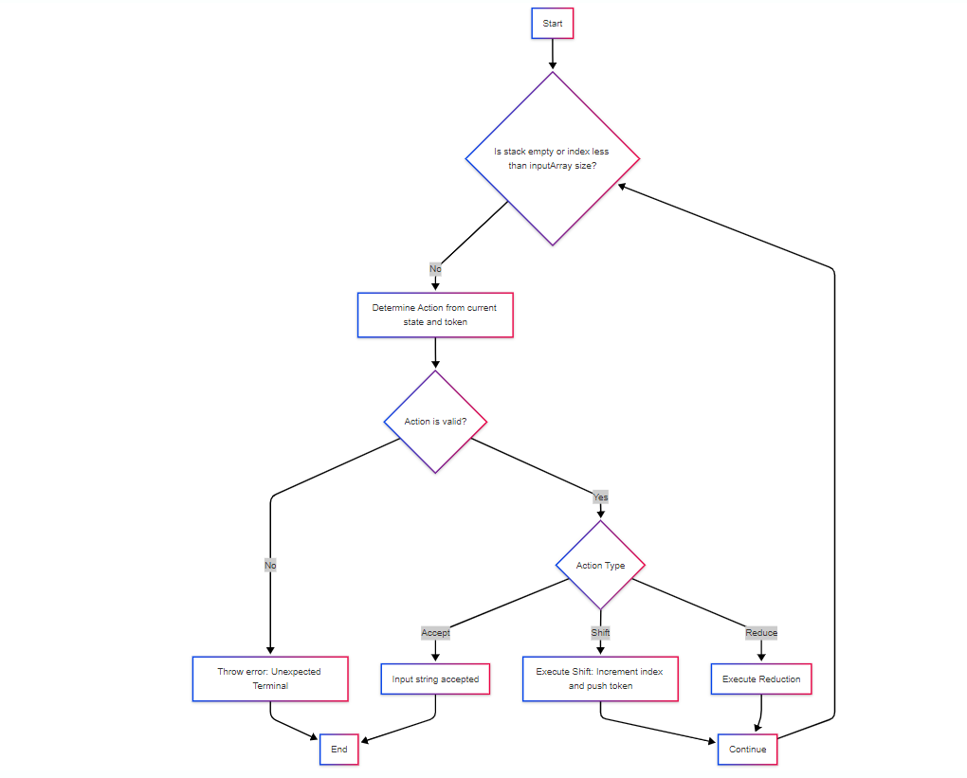
Code: (Available at https://github.com/Debjit-Dhar/CPPython)
- lexer.cpp
#include <cctype>
#include "lexer.hpp"
using namespace std;
// Keywords lookup table
static const unordered_map<string, TokenType> KEYWORD_LOOKUP = {
{"print", PRINT},
{"for", FOR},
{"in", IN},
{"endfor", ENDFOR},
{"int", INT_TYPE},
{"float", FLOAT_TYPE},
{"str", STR_TYPE},
{"bool", BOOL_TYPE},
{"True", TRUE_VALUE},
{"False", FALSE_VALUE},
{"list", LIST_TYPE}
};
// Lexical Analyzer
class Lexer {
private:
const string& input;
size_t pos;
public:
explicit Lexer(const string& input) noexcept : input(input), pos(0) {}
char peek() const { return pos < input.length() ? input[pos] : '\0'; }
char advance() { return pos < input.length() ? input[pos++] : '\0'; }
void skipWhitespaceExceptNewline() {
while (isspace(peek()) && peek() != '\n')
advance();
}
Token getNextToken() {
skipWhitespaceExceptNewline();
if(peek() == '#') {
// Skip comment
while(advance() != '\n');
return {NEWLINE, "\n"};
}
if(peek() == '\'') {
string str;
advance();
while(peek() != '\'') {
str.push_back(peek()); advance();
}
advance();
return {STRING, str};
}
if(peek() == '\"') {
string str;
advance();
while(peek() != '\"') {
str.push_back(peek()); advance();
}
advance();
return {STRING, str};
}

if (isdigit(peek())) { // Integer or Float
string num;
while (isdigit(peek()))
num += advance();
if (peek() == '.') {
num += advance();
while (isdigit(peek()))
num += advance();
return {FLOAT, num};
}
return {INTEGER, num};
}
if (isalpha(peek())) { // Identifiers or Keywords
string id;
while (isalnum(peek()))
id += advance();
auto itr = KEYWORD_LOOKUP.find(id);
if(itr != KEYWORD_LOOKUP.end()) return {itr->second, id};
return {IDENTIFIER, id};
}
switch (advance()) {
case '=':
return {EQUALS, "="};
case '+':
return {PLUS, "+"};
case '-':
return {MINUS, "-"};
case '*':
return {MULT, "*"};
case '/':
return {DIV, "/"};
case '(':
return {OPEN_PAREN, "("};
case ')':
return {CLOSE_PAREN, ")"};
case '[':
return {OPEN_BRACKET, "["};
case ']':
return {CLOSE_BRACKET, "]"};
case ',':
return {COMMA, ","};
case ':':
return {COLON, ":"};
case ';':
return {SEMICOLON, ";"};
case '\n':
return {NEWLINE, "\n"};
case '\0':
return {END_OF_FILE, ""};
default:
return {INVALID, ""};
}
}
};
// Read Python file
string readFile(istream& stream) {
string content((istreambuf_iterator<char>(stream)),
(istreambuf_iterator<char>()));
return content;
}

vector<Token> doLex(const string& text, SymbolTable& symtab) {
vector<Token> arr; Token token;
Lexer lex(text);
do {
token = lex.getNextToken();
arr.push_back(token);
if(token.type == IDENTIFIER) symtab.insert(token.value);
} while (token.type != END_OF_FILE);
return arr;
}
Lexer.hpp
#ifndef __LEXER__
#define __LEXER__
#include <string>
#include <vector>
#include <iostream>
#include <unordered_map>
#include "symtab.hpp
using std::istream;
using std::vector;
using std::string;
using std::unordered_map;
// Explicitly inherit from int to get comparison operators and std::hash. That will be important later
enum TokenType : int {
IDENTIFIER,
INTEGER,
FLOAT,
STRING,
EQUALS,
PLUS,
MINUS,
MULT,
DIV,
PRINT,
FOR,
IN,
ENDFOR,
INT_TYPE,
FLOAT_TYPE,
STR_TYPE,
BOOL_TYPE,
TRUE_VALUE,
FALSE_VALUE,
LIST_TYPE,
OPEN_PAREN,
CLOSE_PAREN,
OPEN_BRACKET,
CLOSE_BRACKET,
COMMA,
COLON,
SEMICOLON,
NEWLINE,
END_OF_FILE,
INVALID,
END_OF_PROGRAM_INDICATOR = END_OF_FILE,

//To indicate empty string, special
EPSILON = -1
};
extern const unordered_map<TokenType, const char *> TOKEN_NAMES;

struct Token {
TokenType type;
string value;
};
string readFile(istream&);
vector<Token> doLex(const string&, SymbolTable&);
#endif

- parser.cpp
#include "parser.hpp"
#include "lexer.hpp"
#include <cassert>
#include <stdexcept>
#include <utility>
using namespace std;
using ParsingStackElement = pair<Symbol, size_t>;
using ParsingStack = vector<ParsingStackElement>;
inline ostream &operator<<(ostream &out, const ParsingStackElement &element) {
out << '(' << element.first << " | state " << element.second << ')';
return out;
}
inline ostream &operator<<(ostream &out, const ParsingStack &pstack) {
if (pstack.empty()) {
out << "empty";
return out;
}
auto itr = pstack.begin();
while (true) {
out << *itr;
itr++;
if (itr == pstack.end())
break;
out << ", ";
}
return out;
}
inline ostream &operator<<(ostream &out, const Token &token) {
out << '[' << TOKEN_NAMES.at(token.type) << " `" << token.value << "`]";
return out;
}
bool parse(const ParsingTable &parsingTable, const GotoTable &gotoTable,
const size_t startState, const vector<Token> &inputArray,
SymbolTable &symbolTable, ostream &out) {
// In its current form, symbol table is unused otherwise.
out<<"Identifiers used from symbol table:\n";
for(const SymbolTable::FullEntry &e : symbolTable) {
out << e.first << endl;
}
out << "\n\n";
ParsingStack stack = {{END_OF_PROGRAM_INDICATOR, startState}};
size_t i = 0; // Index into inputArray
bool errorFlag = false, acceptFlag = false;
Symbol currentSymbol;
size_t currentState;
while (!stack.empty() && i < inputArray.size()) {
currentSymbol = stack.back().first;
currentState = stack.back().second;
out << "\nStack is " << stack << ", current next input token is "
<< inputArray[i] << endl;
Action action;
try {
action = parsingTable[currentState].at(inputArray[i].type);
} catch (const std::out_of_range &ex) {
}
if (!action.index()) {
out << "ERROR! Unexpected terminal.\n";
errorFlag = true;
goto parseEnd;
}
out << "We'll do " << action << endl;
switch (action.index()) {
case 3: // Accept
out << "Input string has been accepted.\n";
acceptFlag = true;
goto parseEnd;
case 1: { // Shift action
const size_t shiftTo = get<size_t>(action);
stack.push_back({inputArray[i].type, shiftTo});
i++;
} break;
case 2: { // Reduce action
const auto &reduction = get<pair<string, Rule>>(action);
const string &nonterminal = reduction.first;
const Rule &production = reduction.second;
for (auto ritr = production.rbegin(); ritr != production.rend(); ritr++) {
currentSymbol = stack.back().first;
currentState = stack.back().second;
assert(currentSymbol == *ritr); // Reduce symbols should match!
stack.pop_back();
}
currentSymbol = stack.back().first;
currentState = stack.back().second;
stack.push_back({nonterminal, gotoTable[currentState].at(nonterminal)});
} break;
}
}
parseEnd:
return acceptFlag && !errorFlag;}
parser.hpp
#ifndef __PARSER__
#define __PARSER__
#include "lexer.hpp"
#include "symtab.hpp"
#include <iostream>
#include <string>
#include <unordered_map>
#include <unordered_set>
#include <variant>
#include <vector>
using namespace std;
// Symbol type. Monostate indicates unassigned.
using Symbol = std::variant<std::monostate, TokenType, std::string>
ostream &operator<<(ostream &, const Symbol &);
// Type for a single rule for a single nonterminal. Length 0 for <epsilon>
using Rule = std::vector<Symbol>;
// Hash for a rule
template <> struct std::hash<Rule> {
// Hashing algorithm taken from Java libraries.
std::size_t operator()(const Rule &rule) const noexcept {
std::hash<Symbol> hasher;
std::size_t result = 1;
for (const Symbol &symbol : rule)
result = 31 * result + hasher(symbol);
return result;
}
};
ostream &operator<<(ostream &, const Rule &);

// Type for a rule set for a rule.
using RuleSet = std::unordered_set<Rule, std::hash<Rule>>;
ostream &operator<<(ostream &, const RuleSet &);
// Represents the language
struct Language {
// Productions
unordered_map<string, RuleSet> prods;
// Priority/precedence sequence of nonterminals, holds ALL nonterminals.
vector<string> order;
// Start symbol pointer
decltype(prods)::iterator startProd;
// First and follow sets
unordered_map<string, unordered_set<TokenType>> first, follow;
void add(const std::string &nt, const RuleSet &rs = RuleSet()) {
bool found = prods.find(nt) != prods.end();
prods[nt] = rs;
if (!found)
order.push_back(nt);
}
void addRule(const string &nt, const Rule &rule) {
prods.at(nt).insert(rule);
}
void setStartSymbol(const string &nt) { startProd = prods.find(nt); }
//void doLeftFactoring();
void genFirstSets();
void genFollowSets();
unordered_set<TokenType> getFirst(const Rule &) const;
private:
//string doLeftFactoring(const string& nt);
};
Language genLanguage();
ostream &operator<<(ostream &, const Language &);
// Item set element (the single row)
class Item {
// The nonterminal of this production
string nonterminal;
// The production
Rule rule;
// Where are we in the production?
size_t currentIndex;
public:
Item(const string &nonterminal = string(), const Rule &rule = Rule(),
size_t currentIndex = 0llu)
: nonterminal(nonterminal), rule(rule) {
this->currentIndex =
currentIndex > rule.size() ? rule.size() : currentIndex;
}
const string &getNonterminal() const noexcept { return nonterminal; }
const Rule &getRule() const noexcept { return rule; }
size_t position() const noexcept { return currentIndex; }
const Symbol &expected_symbol() const noexcept {
return rule.at(currentIndex);
}
bool isAtEnd() const noexcept {return currentIndex >= rule.size();}
bool operator==(const Item &other) const noexcept {
return currentIndex == other.currentIndex &&
nonterminal == other.nonterminal && rule == other.rule;
}
bool operator!=(const Item &other) const noexcept {
return currentIndex != other.currentIndex ||
nonterminal != other.nonterminal || rule != other.rule;
}
Item advancedItem() const noexcept {
return Item(nonterminal, rule, currentIndex+1);
}
};
template <> struct std::hash<Item> {
//Hash an item.
size_t operator()(const Item &item) const noexcept {
std::hash<string> strHasher;
std::hash<Rule> ruleHasher;
return ((31 + item.position()) * 31 + strHasher(item.getNonterminal())) *
31 +
ruleHasher(item.getRule());
}
};
ostream& operator<<(ostream&, const Item&);
//Item set, a single element in the SLR state machine.
using ItemSet = std::unordered_set<Item, std::hash<Item>>;
//Item sets themselves need to be hashable.
template<> struct std::hash<ItemSet> {
size_t operator()(const ItemSet& itemSet) const noexcept {
const auto& itemHasher = itemSet.hash_function();
//Sum the hashes since it should be independent of order.
size_t sum = 0;
for(const Item& item : itemSet) sum += itemHasher(item);
return sum;
}
};
//Get a sorted item set array on the basis of order in language. This is an expensive operation.
vector<Item> sortedItems(const ItemSet&, const Language&);
ostream& operator<<(ostream&, const vector<Item>&);
//Closure function
ItemSet closure(const Item&, const Language&);
//Composite closure function
ItemSet closure(const ItemSet&, const Language&);
//Compute GOTO(itemSet, symbol).
ItemSet computeGoto(const ItemSet& itemSet, const Symbol& symbol, const Language&)
//Unique type for accepting.
struct Accept : public virtual monostate {};
extern const Accept ACCEPT;
//Parsing table action.
//Monostate - uninitialized
//size_t - refers to a state index (shift action) OR a goto state for nonterminals.
//pair - is a production to reduce
//Accept - accept.
using Action = variant<monostate, size_t, pair<string, Rule>, Accept>;
ostream& operator<<(ostream&, const Action&);
using ParsingTable = vector<unordered_map<TokenType, Action>>;
using GotoTable = vector<unordered_map<string, size_t>>;
//Parsing table generator.
struct ParsingTableGenerator {
Language language;
//Should be obvious
ItemSet startState;
//States array.
vector<ItemSet> states;
//State transition table. This is NOT THE PARSING TABLE.
//References indexes from states array and stateIndexes.
//(meaning it maps index and symbol to another index, hence vector.)
vector<unordered_map<Symbol, size_t>> transitions;
//Indexes of states in states array (sort of a reverse mapping.)
unordered_map<ItemSet, size_t> stateIndexes;
//Stores the symbol corresponding to a state (the incoming symbol).
//Map with reference to stateIndexes
vector<Symbol> stateSymbols;
//Parsing table. Similar organisation to transitions table.
ParsingTable parsingTable;
//Goto table. Similar organisation to goto table.
GotoTable gotoTable;
ParsingTableGenerator(const Language& language) : language(language) {
buildTransitions();
buildParsingTable();
}
void printTransitions(ostream&) const;
void printParsingTable(ostream&) const
size_t getStartState() const {return stateIndexes.at(startState);}
private:
//build transition table.
void buildTransitions();
//build parsing table.
void buildParsingTable();
};
//The actual parser. Returns true on successful parse.
bool parse(const ParsingTable&, const GotoTable&, const size_t startState, const vector<Token>& tokenSequence, SymbolTable&, ostream& messages);
#endif

Symbtab.hpp
#ifndef __SYMTAB__
#define __SYMTAB__
#include <string>
#include <unordered_map>
using namespace std
struct SymbolTableEntry {
string identifier;
// Normally other info should be included here, in our given problem
// description we don't need anything extra.
};
class SymbolTable {
unordered_map<string, SymbolTableEntry> data;
public:
bool insert(const string& identifier, const SymbolTableEntry& entry = SymbolTableEntry()) {
bool flag = data.find(identifier) == data.end();
data[identifier] = entry;
data[identifier].identifier = identifier;
return flag;
}
SymbolTableEntry& lookup(const string& identifier) {return data.at(identifier);}
const SymbolTableEntry& lookup(const string& identifier) const {return data.at(identifier);}
using iterator = decltype(data)::iterator;
using const_iterator = decltype(data)::const_iterator;
using FullEntry = decltype(data)::value_type;
iterator begin() {return data.begin();}
const_iterator begin() const {return data.begin();}
iterator end() {return data.end();}
const_iterator end() const {return data.end();}};
#endif

- grammar.cpp
#include "lexer.hpp"
#include "parser.hpp"
#include <variant>
#include <cstdlib>
#include <algorithm>
//#include <utility>
using namespace std;
Language genLanguage() {
Language l;
l.add("program", {{"statement_list"}});
l.add("statement_list", {
{"statement_list", "st_end", "statement"},
{"statement"}
});
l.add("statement", {
{"assignment"},
{"function_call"},
{"for_loop"},
{} //epsilon
});
l.add("st_end", {
{SEMICOLON},
{NEWLINE}
});
l.add("assignment", {{IDENTIFIER, EQUALS, "expression"}});
l.add("function_call", {
{PRINT, OPEN_PAREN, "expression_list", CLOSE_PAREN},
{IDENTIFIER, OPEN_PAREN, "expression_list", CLOSE_PAREN},
{"datatype", OPEN_PAREN, "expression_list", CLOSE_PAREN},
// {OPEN_PAREN, "expression", CLOSE_PAREN, OPEN_PAREN, "expression_list", CLOSE_PAREN}
});
l.add("expression_list", {
{"expression"},
{"expression_list", COMMA, "expression"},
{} //Expressions may be empty
});
l.add("expression", {
{"term"},
{"expression", PLUS, "term"},
{"expression", MINUS, "term"},
});
l.add("term", {
{"factor"},
{"term", MULT, "factor"},
{"term", DIV, "factor"}
});
l.add("factor", {
{IDENTIFIER},
{INTEGER},
{FLOAT},
{STRING},
{"list"},
{TRUE_VALUE},
{FALSE_VALUE},
{"function_call"},
{OPEN_PAREN, "expression", CLOSE_PAREN},
});
l.add("datatype", {
{INT_TYPE},
{FLOAT_TYPE},
{STR_TYPE},
{BOOL_TYPE},
});
l.add("for_loop", {{FOR, IDENTIFIER, IN, "expression", COLON, "statement_list", ENDFOR}});
l.add("list", {{OPEN_BRACKET, "expression_list", CLOSE_BRACKET}});
l.setStartSymbol("program");
for(const auto& e : l.prods) {
for(const auto& r: e.second) {
for(const auto& symbol : r) {
if(holds_alternative<std::string>(symbol) && l.prods.find(get<std::string>(symbol)) == l.prods.end()) {
cerr << "Error! " << symbol << " not in productions!\n";
cerr << "For <" << e.first << "> := " << r << endl;
exit(EXIT_FAILURE);
}
}
}
}
l.genFirstSets();
l.genFollowSets();
return l;
}
ostream& operator<<(ostream& out, const Language& l) {
out << "Grammar rules:\n\n";
for(const string& nt: l.order)
out << '<' << nt << "> ::= " << l.prods.at(nt) << "\n\n";
out << "\nFirst sets:\n";
for(const string& nt : l.order) {
out << '<' << nt << "> ::= {";
vector<TokenType> first;
{
const auto& firstSet = l.getFirst({nt});
first.reserve(firstSet.size());
first.insert(first.end(), firstSet.begin(), firstSet.end());
sort(first.begin(), first.end());
}
auto itr = first.begin();
while(itr != first.end()) {
out << Symbol(*itr); itr++;
if(itr == first.end()) break;
out << ", ";
}
out << "}\n";
}
out << "\nFollow sets:\n";
for(const string& nt : l.order) {
out << '<' << nt << "> ::= {";
vector<TokenType> follow;
{
const auto& followSet = l.follow.at(nt);
follow.reserve(followSet.size());
follow.insert(follow.end(), followSet.begin(), followSet.end());
sort(follow.begin(), follow.end());
}
auto itr = follow.begin();
while(itr != follow.end()) {
out << Symbol(*itr); itr++;
if(itr == follow.end()) break;
out << ", ";
}
out << "}\n";
}
out << endl;
return out;
}
ostream& operator<<(ostream& out, const RuleSet& rs) {
if(rs.empty()) return out;
auto itr = rs.begin();
while(true) {
out << *itr; itr++;
if(itr == rs.end()) break;
else out << " | ";
}
return out;

ostream& operator<<(ostream& out, const Rule& rule) {
if(rule.empty()) {
out << "<epsilon!>";
return out;
}
auto itr = rule.begin();
while(true) {
out << *itr; itr++;
if(itr == rule.end()) break;
else out << ' ';
}
return out;
}
const unordered_map<TokenType, const char *> TOKEN_NAMES = {
{IDENTIFIER, "IDENTIFIER"},
{INTEGER, "INTEGER"},
{FLOAT, "FLOAT"},
{STRING, "STRING"},
{EQUALS, "EQUALS"},
{PLUS, "PLUS"},
{MINUS, "MINUS"},
{MULT, "MULT"},
{DIV, "DIV"},
{PRINT, "PRINT"},
{FOR, "FOR"},
{IN, "IN"},
{ENDFOR, "ENDFOR"},
{INT_TYPE, "INT_TYPE"},
{FLOAT_TYPE, "FLOAT_TYPE"},
{STR_TYPE, "STR_TYPE"},
{BOOL_TYPE, "BOOL_TYPE"},
{TRUE_VALUE, "TRUE_VALUE"},
{FALSE_VALUE, "FALSE_VALUE"},
{LIST_TYPE, "LIST_TYPE"},
{OPEN_PAREN, "OPEN_PAREN"},
{CLOSE_PAREN, "CLOSE_PAREN"},
{OPEN_BRACKET, "OPEN_BRACKET"},
{CLOSE_BRACKET, "CLOSE_BRACKET"},
{COMMA, "COMMA"},
{COLON, "COLON"},
{SEMICOLON, "SEMICOLON"},
{NEWLINE, "NEWLINE"},
{END_OF_FILE, "END_OF_FILE"},
{INVALID, "INVALID"},
{EPSILON, "<empty string>"}
};
ostream& operator<<(ostream& out, const Symbol& symbol) {
switch(symbol.index()) {
case 1llu: out << TOKEN_NAMES.at(get<TokenType>(symbol)); break;
case 2llu: out << '<' << get<std::string>(symbol) << '>'; break;
default: out << "!!no such symbol!!"; break;
}
return out;
}
- firstfollow.cpp
#include "lexer.hpp"
#include "parser.hpp"
#include <unordered_set>
#include <unordered_map>
#include <cassert>
#include <utility>
#include <variant>
using namespace std;
void Language::genFirstSets() {
first.clear();
bool runScan;
do {
runScan = false;
//`cout<<"Doing scan...\n";
for(const string& nonterminal : order) {
//Does this work? Do we get a clean default empty set?
unordered_set<TokenType> oldSet, newSet;
{
auto itr = first.find(nonterminal);
if(itr != first.end()) newSet = oldSet = itr->second;
}
const auto& ruleset = prods[nonterminal];
bool nullable = false; //Can this nonterminal produce an empty string?
for(const auto& rule : ruleset) {
bool productionNullable = true; //Does this production/ruleset produce an empty string?
for(const Symbol& symbol : rule) {
unordered_set<TokenType> symbolFirst;
assert(symbol.index() > 0);
switch(symbol.index()) {
case 1: symbolFirst.insert(get<TokenType>(symbol)); break;
case 2: {
auto itr = first.find(get<std::string>(symbol));
if(itr != first.end()) symbolFirst = itr->second;
} break;
}
newSet.insert(symbolFirst.begin(), symbolFirst.end());
newSet.erase(EPSILON);
//This symbol in rule is not nullable
if(symbolFirst.find(EPSILON) == symbolFirst.end()) {
productionNullable = false; break;
}
}
nullable = nullable || productionNullable;
}
if (nullable) newSet.insert(EPSILON);
runScan = runScan || oldSet != newSet;
// cout << '<' << nonterminal << "> ::= {";
// auto itr = newSet.begin();
// while(itr != newSet.end()) {
// cout << Symbol(*itr); itr++;
// if(itr == newSet.end()) break;
// cout << ", ";
// }
// cout << "}\n";
first[nonterminal] = std::move(newSet);
}
// cout << endl;
// for(const string& nt: order) {
// cout << '<' << nt << "> ::= {";
// unordered_set<TokenType> firstSet;
// {
// auto itr = first.find(nt);
// if(itr != first.end()) firstSet = itr->second;
// }
// auto itr = firstSet.begin();
// while(itr != firstSet.end()) {
// cout << Symbol(*itr); itr++;
// if(itr == firstSet.end()) break;
// cout << ", ";
// }
// cout << "}\n";
// }
// cout << "\n\n";
} while (runScan);
}
void Language::genFollowSets() {
if(first.empty()) genFirstSets();
follow.clear()
follow[startProd->first] = {END_OF_PROGRAM_INDICATOR};
bool runScan;
do {
runScan = false;
for(const string& nonterminal : order) {
const RuleSet& rs = prods[nonterminal];
for(const Rule& rule : rs) {
for(auto i = rule.begin(); i != rule.end(); i++) {
if(!holds_alternative<std::string>(*i)) continue;
const string& targetSymbol = get<std::string>(*i);

unordered_set<TokenType> oldSet, newSet, alphaSet, betaSet;
//Old follow set of the symbol we are modifying
{
auto itr = follow.find(targetSymbol);
if(itr != follow.end()) newSet = oldSet = itr->second;
}
//Follow set of the parent nonterminal this production comes from
{
auto itr = follow.find(nonterminal);
if(itr != follow.end()) alphaSet = itr->second;
}
//First set of the REST of the production
betaSet = getFirst(Rule(i + 1, rule.end()));
newSet.insert(betaSet.begin(), betaSet.end());
newSet.erase(EPSILON);
//Add follow set of parent nonterminal if production results in epsilon
if(betaSet.find(EPSILON) != betaSet.end())
newSet.insert(alphaSet.begin(), alphaSet.end());

runScan = runScan || oldSet != newSet;
follow[targetSymbol] = newSet;
}
}
}
} while (runScan);
}
unordered_set<TokenType> Language::getFirst(const Rule& seq) const {
if(seq.empty()) return {EPSILON};
unordered_set<TokenType> result;
for(const Symbol& symbol: seq) {
unordered_set<TokenType> symbolFirst;
assert(symbol.index() > 0);
switch(symbol.index()) {
case 1: symbolFirst.insert(get<TokenType>(symbol)); break;
case 2: symbolFirst = first.at(get<string>(symbol)); break;
}
result.insert(symbolFirst.begin(), symbolFirst.end());
if(symbolFirst.find(EPSILON) == symbolFirst.end()) {
result.erase(EPSILON); break;
}
}
return result;
}

- Item.cpp
#include "parser.hpp"
#include <algorithm>
#include <stack>
#include <variant>
#include <utility>
using namespace std;
ostream &operator<<(ostream &out, const Item &item) {
out << '<' << item.getNonterminal() << "> ::= ";
for (size_t i = 0; i < item.getRule().size(); i++) {
if (i == item.position())
out << ". ";
out << item.getRule()[i];
if (i < (item.getRule().size() - 1))
out << ' ';
}
if(item.position() == item.getRule().size()) out << " .";
return out;
}
ostream &operator<<(ostream& out, const vector<Item>& items) {
for(const Item& item : items) out << item << endl;
return out;
}
vector<Item> sortedItems(const ItemSet &itemSet, const Language &l) {
struct ItemComparator {
unordered_map<string, size_t> keys;
ItemComparator(const Language &l) {
for (size_t i = 0; i < l.order.size(); i++)
keys[l.order[i]] = i;
}
// is left < right?
bool operator()(const Item &left, const Item &right) const {
auto k1 = keys.at(left.getNonterminal());
auto k2 = keys.at(right.getNonterminal());
if(k1 < k2) return true;
else if(k1 > k2) return false;
k1 = left.position(); k2 = right.position();
if(k1 < k2) return true;
else if(k1 > k2) return false;
return left.getRule() < right.getRule();
}
};
vector<Item> result = vector<Item>(itemSet.begin(), itemSet.end());
sort(result.begin(), result.end(), ItemComparator(l));
return result;
}
ItemSet closure(const Item &i, const Language &l) {
ItemSet result;
// A sort of depth-first search for closure.
stack<Item> stck;
stck.push(i);
while (!stck.empty()) {
const Item item = std::move(stck.top());
stck.pop();
if (result.find(item) != result.end())
continue;
result.insert(item);
//Note: short-circuit operator is important here.
if (item.isAtEnd() || !holds_alternative<string>(item.expected_symbol()))
continue;
const string& newNonterminal = get<string>(item.expected_symbol());
for(const Rule& rule : l.prods.at(newNonterminal))
stck.push(Item(newNonterminal, rule, 0));
}
return result;
}
ItemSet closure(const ItemSet& itemSet, const Language& l) {
ItemSet result;
for(const Item& item : itemSet) {
const ItemSet& partial = closure(item, l);
result.insert(partial.begin(), partial.end());
}
return result;
}
ItemSet computeGoto(const ItemSet& itemSet, const Symbol& symbol, const Language& l) {
ItemSet targetItemSet;
for(const Item& item : itemSet) {
if(item.isAtEnd()) continue; //This is a termination state.
if(item.expected_symbol() == symbol) targetItemSet.insert(item.advancedItem());
}
return closure(targetItemSet, l);
}

- tablegen.cpp
#include "parser.hpp"
#include "lexer.hpp"
#include <stack>
#include <utility>
#include <cstdlib>
#include <stdexcept>
using namespace std;
const Accept ACCEPT = Accept();
void ParsingTableGenerator::buildTransitions() {
// Depth-first search to generate all possible states
stack<ItemSet> unmarkedStates;
unmarkedStates.push(startState = closure(
Item(language.startProd->first, *(language.startProd->second.begin()), 0),
language));
while (!unmarkedStates.empty()) {
const ItemSet state = std::move(unmarkedStates.top());
unmarkedStates.pop();
if (stateIndexes.find(state) != stateIndexes.end())
continue;
stateIndexes[state] = states.size();
states.push_back(state);
for (const string &target : language.order) {
const auto &targetState = computeGoto(state, Symbol(target), language);
if (targetState.empty())
continue;
unmarkedStates.push(targetState);
}
for (const auto &e : TOKEN_NAMES) {
const Symbol &target = Symbol(e.first);
const auto &targetState = computeGoto(state, target, language);
if (targetState.empty())
continue;
unmarkedStates.push(targetState);
}
}
stateSymbols.resize(states.size());
transitions.resize(states.size());
stateSymbols[0] = END_OF_PROGRAM_INDICATOR;
for(size_t i = 0; i < states.size(); i++) {
for(const string& target : language.order) {
const Symbol& targetSymbol = target;
const auto &targetState = computeGoto(states[i], targetSymbol, language);
if (targetState.empty())
continue;
//Insert in transition table
size_t targetStateIndex = transitions[i][targetSymbol] = stateIndexes[targetState];
if(!stateSymbols[targetStateIndex].index()) stateSymbols[targetStateIndex] = targetSymbol;
else if(stateSymbols[targetStateIndex] != targetSymbol) {
cerr << "ERROR! Given grammar is not LR(0).\n";
cerr << "For state at index " << targetStateIndex << ":\n";
cerr << sortedItems(targetState, language) << endl;
cerr << "This has multiple incoming symbols: " << targetSymbol << " and " << stateSymbols[targetStateIndex];
exit(EXIT_FAILURE);
}
}
for(const auto& e : TOKEN_NAMES) {
const Symbol& targetSymbol = e.first;
const auto &targetState = computeGoto(states[i], targetSymbol, language);
if (targetState.empty())
continue;
//Insert in transition table
size_t targetStateIndex = transitions[i][targetSymbol] = stateIndexes[targetState];
if(!stateSymbols[targetStateIndex].index()) stateSymbols[targetStateIndex] = targetSymbol;
else if(stateSymbols[targetStateIndex] != targetSymbol) {
cerr << "ERROR! Given grammar is not LR(0).\n";
cerr << "For state at index " << targetStateIndex << ":\n";
cerr << sortedItems(targetState, language) << endl;
cerr << "This has multiple incoming symbols: " << targetSymbol << " and " << stateSymbols[targetStateIndex];
exit(EXIT_FAILURE);
}
}
}
}
void ParsingTableGenerator::printTransitions(ostream& out) const {
for(size_t i = 0; i < states.size(); i++) {
out << "\nState " << i << ":\n";
if(startState == states[i]) out << "This is the start state\n";
out << "Corresponding symbol is " << stateSymbols[i] << endl;
out << sortedItems(states[i], language) << endl;
for(const string& target : language.order) {
const Symbol& targetSymbol = target;
try {
size_t targetStateIndex = transitions[i].at(targetSymbol);
out << "On " << targetSymbol << ", go to " << targetStateIndex << endl;
} catch (const std::out_of_range &ex) {}
}
for(const auto& e : TOKEN_NAMES) {
const Symbol& targetSymbol = e.first;
try {
size_t targetStateIndex = transitions[i].at(targetSymbol);
out << "On " << targetSymbol << ", go to " << targetStateIndex << endl;
} catch (const std::out_of_range &ex) {}
}
out << endl;
}
}
void ParsingTableGenerator::buildParsingTable() {
//printTransitions(cout);
parsingTable.resize(states.size());
gotoTable.resize(states.size());
for(size_t state_number = 0; state_number < states.size(); state_number++) {
const ItemSet& itemSet = states[state_number];
for(const Item& item : itemSet) {
if(item.isAtEnd()) {
//Create reduce actions
for(const TokenType& terminal : language.follow.at(item.getNonterminal())) {
Action newAction = Action(pair<string, Rule>(item.getNonterminal(), item.getRule()));
{
auto itr = parsingTable[state_number].find(terminal);
if(itr != parsingTable[state_number].end()) {
const Action& oldAction = itr->second;
if(oldAction.index() && oldAction != newAction) {
//Error. More than one entry in table at once.
cerr << "ERROR! Given grammar is not LR(0).\n";
cerr << "For state " << state_number << " and input token " << TOKEN_NAMES.at(terminal);
cerr << ", we have two possible actions: " << oldAction << " and " << newAction << endl;
exit(EXIT_FAILURE);
}
}
}
parsingTable[state_number][terminal] = newAction;
}
//At end of start symbol?
if(item.getNonterminal() == language.startProd->first)
parsingTable[state_number][END_OF_PROGRAM_INDICATOR] = ACCEPT;
}
else {
//Is a terminal expected next?
if(holds_alternative<TokenType>(item.expected_symbol())) {
const TokenType terminal = get<TokenType>(item.expected_symbol());
Action newAction = transitions[state_number].at(item.expected_symbol());
{
auto itr = parsingTable[state_number].find(terminal);
if(itr != parsingTable[state_number].end()) {
const Action& oldAction = itr->second;
if(oldAction.index() && oldAction != newAction) {
//Error. More than one entry in table at once.
cerr << "ERROR! Given grammar is not LR(0).\n";
cerr << "For state " << state_number << " and input token " << TOKEN_NAMES.at(terminal);
cerr << ", we have two possible actions: " << oldAction << " and " << newAction << endl;
exit(EXIT_FAILURE);
}
}
}
parsingTable[state_number][terminal] = newAction;
}
//Else expected a nonterminal next. Fill goto table
else {
const string& nonterminal = get<string>(item.expected_symbol());
size_t newGoto = transitions[state_number].at(item.expected_symbol());
{
auto itr = gotoTable[state_number].find(nonterminal);
if(itr != gotoTable[state_number].end() && itr->second != newGoto) {
size_t oldGoto = itr->second;
cerr << "ERROR! Given grammar is not LR(0).\n";
cerr << "For state " << state_number << " and goto nonterminal " << nonterminal;
cerr << ", we have two possible actions: goto state " << oldGoto << " and goto state " << newGoto << endl;
exit(EXIT_FAILURE);
}
}
gotoTable[state_number][nonterminal] = newGoto;
}
}
}
}
}
void ParsingTableGenerator::printParsingTable(ostream& out) const {
for(size_t state_number = 0; state_number < states.size(); state_number++) {
out << "For state " << state_number << ":\n";
for(const auto& e : TOKEN_NAMES) {
const TokenType terminal = e.first;
try {
const auto& action = parsingTable[state_number].at(terminal);
out << "For terminal " << e.second << ", do " << action << endl;
} catch (const std::out_of_range &ex) {}
}
for(const string& nonterminal : language.order) {
try {
size_t theGoto = gotoTable[state_number].at(nonterminal);
out << "For nonterminal " << nonterminal << ", goto state " << theGoto << endl;
} catch (const std::out_of_range &ex) {}
}
out << endl;
}
}
ostream& operator<<(ostream& out, const Action& action) {
switch(action.index()) {
case 1: out << "shift to state " << get<size_t>(action); break;
case 2: {
const auto& p = get<pair<string, Rule>>(action);
out << "reduce <" << p.first << "> ::= " << p.second;
} break;
case 3: out << "ACCEPT."; break;
default: out << "!!no such action!!"; break;
}
return out;
}

- main.cpp
#include "parser.hpp"
#include "lexer.hpp"
#include "symtab.hpp"
#include <iostream>
#include <fstream>
#include <cstdlib>
#include <cerrno>
#include <cstring>
#include <utility>
using namespace std;
int main(int argc, char *argv[]) {
//First build the parser
ParsingTable parsingTable;
GotoTable gotoTable;
SymbolTable symbolTable;
size_t startState;
{
//Output language info into this file
ofstream info = ofstream("grammar.txt");
Language language = genLanguage();
info << "Language information:\n" << language << endl;
ParsingTableGenerator p = ParsingTableGenerator(language);
info << "\nState transitions:\n";
p.printTransitions(info);
info << "\nParsing table:\n";
p.printParsingTable(info);
info.close();
startState = p.getStartState();
parsingTable = std::move(p.parsingTable);
gotoTable = std::move(p.gotoTable);
}
if(argc < 2) {
cerr << "Usage: " << argv[0] << " <input file>\n";
return EXIT_FAILURE;
}
vector<Token> tokens;
{
ifstream file = ifstream(argv[1]);
if(!file) {
cerr << "ERROR! Couldn't read file: " << strerror(errno) << endl;
return EXIT_FAILURE;
}
tokens = doLex(readFile(file), symbolTable);
file.close();
}
return parse(parsingTable, gotoTable, startState, tokens, symbolTable, cout) ? EXIT_SUCCESS : EXIT_FAILURE;
}

Grammar Information (autogenerated as part of program):
Grammar
Language information:
Grammar rules:

<program> ::= <statement_list>

<statement_list> ::= <statement> | <statement_list> <st_end> <statement>

<statement> ::= <epsilon!> | <for_loop> | <function_call> | <assignment>

<st_end> ::= NEWLINE | SEMICOLON

<assignment> ::= IDENTIFIER EQUALS <expression>

<function_call> ::= <datatype> OPEN_PAREN <expression_list> CLOSE_PAREN | IDENTIFIER OPEN_PAREN <expression_list> CLOSE_PAREN | PRINT OPEN_PAREN <expression_list> CLOSE_PAREN

<expression_list> ::= <epsilon!> | <expression_list> COMMA <expression> | <expression>

<expression> ::= <expression> MINUS <term> | <expression> PLUS <term> | <term>

<term> ::= <term> DIV <factor> | <term> MULT <factor> | <factor>

<factor> ::= OPEN_PAREN <expression> CLOSE_PAREN | <function_call> | FALSE_VALUE | TRUE_VALUE | <list> | STRING | FLOAT | INTEGER | IDENTIFIER

<datatype> ::= LIST_TYPE | BOOL_TYPE | STR_TYPE | FLOAT_TYPE | INT_TYPE

<for_loop> ::= FOR IDENTIFIER IN <expression> COLON <statement_list> ENDFOR

<list> ::= OPEN_BRACKET <expression_list> CLOSE_BRACKET

First sets:
<program> ::= {<empty string>, IDENTIFIER, PRINT, FOR, INT_TYPE, FLOAT_TYPE, STR_TYPE, BOOL_TYPE, LIST_TYPE, SEMICOLON, NEWLINE}
<statement_list> ::= {<empty string>, IDENTIFIER, PRINT, FOR, INT_TYPE, FLOAT_TYPE, STR_TYPE, BOOL_TYPE, LIST_TYPE, SEMICOLON, NEWLINE}
<statement> ::= {<empty string>, IDENTIFIER, PRINT, FOR, INT_TYPE, FLOAT_TYPE, STR_TYPE, BOOL_TYPE, LIST_TYPE}
<st_end> ::= {SEMICOLON, NEWLINE}
<assignment> ::= {IDENTIFIER}
<function_call> ::= {IDENTIFIER, PRINT, INT_TYPE, FLOAT_TYPE, STR_TYPE, BOOL_TYPE, LIST_TYPE}
<expression_list> ::= {<empty string>, IDENTIFIER, INTEGER, FLOAT, STRING, PRINT, INT_TYPE, FLOAT_TYPE, STR_TYPE, BOOL_TYPE, TRUE_VALUE, FALSE_VALUE, LIST_TYPE, OPEN_PAREN, OPEN_BRACKET, COMMA}
<expression> ::= {IDENTIFIER, INTEGER, FLOAT, STRING, PRINT, INT_TYPE, FLOAT_TYPE, STR_TYPE, BOOL_TYPE, TRUE_VALUE, FALSE_VALUE, LIST_TYPE, OPEN_PAREN, OPEN_BRACKET}
<term> ::= {IDENTIFIER, INTEGER, FLOAT, STRING, PRINT, INT_TYPE, FLOAT_TYPE, STR_TYPE, BOOL_TYPE, TRUE_VALUE, FALSE_VALUE, LIST_TYPE, OPEN_PAREN, OPEN_BRACKET}
<factor> ::= {IDENTIFIER, INTEGER, FLOAT, STRING, PRINT, INT_TYPE, FLOAT_TYPE, STR_TYPE, BOOL_TYPE, TRUE_VALUE, FALSE_VALUE, LIST_TYPE, OPEN_PAREN, OPEN_BRACKET}
<datatype> ::= {INT_TYPE, FLOAT_TYPE, STR_TYPE, BOOL_TYPE, LIST_TYPE}
<for_loop> ::= {FOR}
<list> ::= {OPEN_BRACKET}

Follow sets:
<program> ::= {END_OF_FILE}
<statement_list> ::= {ENDFOR, SEMICOLON, NEWLINE, END_OF_FILE}
<statement> ::= {ENDFOR, SEMICOLON, NEWLINE, END_OF_FILE}
<st_end> ::= {IDENTIFIER, PRINT, FOR, ENDFOR, INT_TYPE, FLOAT_TYPE, STR_TYPE, BOOL_TYPE, LIST_TYPE, SEMICOLON, NEWLINE, END_OF_FILE}
<assignment> ::= {ENDFOR, SEMICOLON, NEWLINE, END_OF_FILE}
<function_call> ::= {PLUS, MINUS, MULT, DIV, ENDFOR, CLOSE_PAREN, CLOSE_BRACKET, COMMA, COLON, SEMICOLON, NEWLINE, END_OF_FILE}
<expression_list> ::= {CLOSE_PAREN, CLOSE_BRACKET, COMMA}
<expression> ::= {PLUS, MINUS, ENDFOR, CLOSE_PAREN, CLOSE_BRACKET, COMMA, COLON, SEMICOLON, NEWLINE, END_OF_FILE}
<term> ::= {PLUS, MINUS, MULT, DIV, ENDFOR, CLOSE_PAREN, CLOSE_BRACKET, COMMA, COLON, SEMICOLON, NEWLINE, END_OF_FILE}
<factor> ::= {PLUS, MINUS, MULT, DIV, ENDFOR, CLOSE_PAREN, CLOSE_BRACKET, COMMA, COLON, SEMICOLON, NEWLINE, END_OF_FILE}
<datatype> ::= {OPEN_PAREN}
<for_loop> ::= {ENDFOR, SEMICOLON, NEWLINE, END_OF_FILE}
<list> ::= {PLUS, MINUS, MULT, DIV, ENDFOR, CLOSE_PAREN, CLOSE_BRACKET, COMMA, COLON, SEMICOLON, NEWLINE, END_OF_FILE}

State transitions:

State 0:
This is the start state
Corresponding symbol is END_OF_FILE
<program> ::= . <statement_list>
<statement_list> ::= . <statement>
<statement_list> ::= . <statement_list> <st_end> <statement>
<statement> ::= .
<statement> ::= . <assignment>
<statement> ::= . <for_loop>
<statement> ::= . <function_call>
<assignment> ::= . IDENTIFIER EQUALS <expression>
<function_call> ::= . IDENTIFIER OPEN_PAREN <expression_list> CLOSE_PAREN
<function_call> ::= . PRINT OPEN_PAREN <expression_list> CLOSE_PAREN
<function_call> ::= . <datatype> OPEN_PAREN <expression_list> CLOSE_PAREN
<datatype> ::= . INT_TYPE
<datatype> ::= . FLOAT_TYPE
<datatype> ::= . STR_TYPE
<datatype> ::= . BOOL_TYPE
<datatype> ::= . LIST_TYPE
<for_loop> ::= . FOR IDENTIFIER IN <expression> COLON <statement_list> ENDFOR

On <statement_list>, go to 62
On <statement>, go to 55
On <assignment>, go to 54
On <function_call>, go to 53
On <datatype>, go to 19
On <for_loop>, go to 52
On FOR, go to 47
On PRINT, go to 16
On IDENTIFIER, go to 6
On INT_TYPE, go to 5
On FLOAT_TYPE, go to 4
On STR_TYPE, go to 3
On BOOL_TYPE, go to 2
On LIST_TYPE, go to 1

State 1:
Corresponding symbol is LIST_TYPE
<datatype> ::= LIST_TYPE .

State 2:
Corresponding symbol is BOOL_TYPE
<datatype> ::= BOOL_TYPE .

State 3:
Corresponding symbol is STR_TYPE
<datatype> ::= STR_TYPE .

State 4:
Corresponding symbol is FLOAT_TYPE
<datatype> ::= FLOAT_TYPE .

State 5:
Corresponding symbol is INT_TYPE
<datatype> ::= INT_TYPE .

State 6:
Corresponding symbol is IDENTIFIER
<assignment> ::= IDENTIFIER . EQUALS <expression>
<function_call> ::= IDENTIFIER . OPEN_PAREN <expression_list> CLOSE_PAREN

On EQUALS, go to 45
On OPEN_PAREN, go to 7

State 7:
Corresponding symbol is OPEN_PAREN
<function_call> ::= . IDENTIFIER OPEN_PAREN <expression_list> CLOSE_PAREN
<function_call> ::= . PRINT OPEN_PAREN <expression_list> CLOSE_PAREN
<function_call> ::= . <datatype> OPEN_PAREN <expression_list> CLOSE_PAREN
<function_call> ::= IDENTIFIER OPEN_PAREN . <expression_list> CLOSE_PAREN
<expression_list> ::= .
<expression_list> ::= . <expression>
<expression_list> ::= . <expression_list> COMMA <expression>
<expression> ::= . <expression> PLUS <term>
<expression> ::= . <expression> MINUS <term>
<expression> ::= . <term>
<term> ::= . <factor>
<term> ::= . <term> MULT <factor>
<term> ::= . <term> DIV <factor>
<factor> ::= . IDENTIFIER
<factor> ::= . INTEGER
<factor> ::= . FLOAT
<factor> ::= . STRING
<factor> ::= . TRUE_VALUE
<factor> ::= . FALSE_VALUE
<factor> ::= . OPEN_PAREN <expression> CLOSE_PAREN
<factor> ::= . <function_call>
<factor> ::= . <list>
<datatype> ::= . INT_TYPE
<datatype> ::= . FLOAT_TYPE
<datatype> ::= . STR_TYPE
<datatype> ::= . BOOL_TYPE
<datatype> ::= . LIST_TYPE
<list> ::= . OPEN_BRACKET <expression_list> CLOSE_BRACKET

On <function_call>, go to 25
On <expression_list>, go to 43
On <expression>, go to 28
On <term>, go to 22
On <factor>, go to 21
On <datatype>, go to 19
On <list>, go to 18
On PRINT, go to 16
On STRING, go to 15
On FLOAT, go to 14
On INTEGER, go to 13
On IDENTIFIER, go to 12
On INT_TYPE, go to 5
On FLOAT_TYPE, go to 4
On STR_TYPE, go to 3
On BOOL_TYPE, go to 2
On TRUE_VALUE, go to 11
On FALSE_VALUE, go to 10
On LIST_TYPE, go to 1
On OPEN_PAREN, go to 9
On OPEN_BRACKET, go to 8

State 8:
Corresponding symbol is OPEN_BRACKET
<function_call> ::= . IDENTIFIER OPEN_PAREN <expression_list> CLOSE_PAREN
<function_call> ::= . PRINT OPEN_PAREN <expression_list> CLOSE_PAREN
<function_call> ::= . <datatype> OPEN_PAREN <expression_list> CLOSE_PAREN
<expression_list> ::= .
<expression_list> ::= . <expression>
<expression_list> ::= . <expression_list> COMMA <expression>
<expression> ::= . <expression> PLUS <term>
<expression> ::= . <expression> MINUS <term>
<expression> ::= . <term>
<term> ::= . <factor>
<term> ::= . <term> MULT <factor>
<term> ::= . <term> DIV <factor>
<factor> ::= . IDENTIFIER
<factor> ::= . INTEGER
<factor> ::= . FLOAT
<factor> ::= . STRING
<factor> ::= . TRUE_VALUE
<factor> ::= . FALSE_VALUE
<factor> ::= . OPEN_PAREN <expression> CLOSE_PAREN
<factor> ::= . <function_call>
<factor> ::= . <list>
<datatype> ::= . INT_TYPE
<datatype> ::= . FLOAT_TYPE
<datatype> ::= . STR_TYPE
<datatype> ::= . BOOL_TYPE
<datatype> ::= . LIST_TYPE
<list> ::= . OPEN_BRACKET <expression_list> CLOSE_BRACKET
<list> ::= OPEN_BRACKET . <expression_list> CLOSE_BRACKET

On <function_call>, go to 25
On <expression_list>, go to 41
On <expression>, go to 28
On <term>, go to 22
On <factor>, go to 21
On <datatype>, go to 19
On <list>, go to 18
On PRINT, go to 16
On STRING, go to 15
On FLOAT, go to 14
On INTEGER, go to 13
On IDENTIFIER, go to 12
On INT_TYPE, go to 5
On FLOAT_TYPE, go to 4
On STR_TYPE, go to 3
On BOOL_TYPE, go to 2
On TRUE_VALUE, go to 11
On FALSE_VALUE, go to 10
On LIST_TYPE, go to 1
On OPEN_PAREN, go to 9
On OPEN_BRACKET, go to 8

State 9:
Corresponding symbol is OPEN_PAREN
<function_call> ::= . IDENTIFIER OPEN_PAREN <expression_list> CLOSE_PAREN
<function_call> ::= . PRINT OPEN_PAREN <expression_list> CLOSE_PAREN
<function_call> ::= . <datatype> OPEN_PAREN <expression_list> CLOSE_PAREN
<expression> ::= . <expression> PLUS <term>
<expression> ::= . <expression> MINUS <term>
<expression> ::= . <term>
<term> ::= . <factor>
<term> ::= . <term> MULT <factor>
<term> ::= . <term> DIV <factor>
<factor> ::= . IDENTIFIER
<factor> ::= . INTEGER
<factor> ::= . FLOAT
<factor> ::= . STRING
<factor> ::= . TRUE_VALUE
<factor> ::= . FALSE_VALUE
<factor> ::= . OPEN_PAREN <expression> CLOSE_PAREN
<factor> ::= . <function_call>
<factor> ::= . <list>
<factor> ::= OPEN_PAREN . <expression> CLOSE_PAREN
<datatype> ::= . INT_TYPE
<datatype> ::= . FLOAT_TYPE
<datatype> ::= . STR_TYPE
<datatype> ::= . BOOL_TYPE
<datatype> ::= . LIST_TYPE
<list> ::= . OPEN_BRACKET <expression_list> CLOSE_BRACKET

On <function_call>, go to 25
On <expression>, go to 39
On <term>, go to 22
On <factor>, go to 21
On <datatype>, go to 19
On <list>, go to 18
On PRINT, go to 16
On STRING, go to 15
On FLOAT, go to 14
On INTEGER, go to 13
On IDENTIFIER, go to 12
On INT_TYPE, go to 5
On FLOAT_TYPE, go to 4
On STR_TYPE, go to 3
On BOOL_TYPE, go to 2
On TRUE_VALUE, go to 11
On FALSE_VALUE, go to 10
On LIST_TYPE, go to 1
On OPEN_PAREN, go to 9
On OPEN_BRACKET, go to 8

State 10:
Corresponding symbol is FALSE_VALUE
<factor> ::= FALSE_VALUE .

State 11:
Corresponding symbol is TRUE_VALUE
<factor> ::= TRUE_VALUE .

State 12:
Corresponding symbol is IDENTIFIER
<function_call> ::= IDENTIFIER . OPEN_PAREN <expression_list> CLOSE_PAREN
<factor> ::= IDENTIFIER .

On OPEN_PAREN, go to 7

State 13:
Corresponding symbol is INTEGER
<factor> ::= INTEGER .

State 14:
Corresponding symbol is FLOAT
<factor> ::= FLOAT .

State 15:
Corresponding symbol is STRING
<factor> ::= STRING .

State 16:
Corresponding symbol is PRINT
<function_call> ::= PRINT . OPEN_PAREN <expression_list> CLOSE_PAREN

On OPEN_PAREN, go to 17

State 17:
Corresponding symbol is OPEN_PAREN
<function_call> ::= . IDENTIFIER OPEN_PAREN <expression_list> CLOSE_PAREN
<function_call> ::= . PRINT OPEN_PAREN <expression_list> CLOSE_PAREN
<function_call> ::= . <datatype> OPEN_PAREN <expression_list> CLOSE_PAREN
<function_call> ::= PRINT OPEN_PAREN . <expression_list> CLOSE_PAREN
<expression_list> ::= .
<expression_list> ::= . <expression>
<expression_list> ::= . <expression_list> COMMA <expression>
<expression> ::= . <expression> PLUS <term>
<expression> ::= . <expression> MINUS <term>
<expression> ::= . <term>
<term> ::= . <factor>
<term> ::= . <term> MULT <factor>
<term> ::= . <term> DIV <factor>
<factor> ::= . IDENTIFIER
<factor> ::= . INTEGER
<factor> ::= . FLOAT
<factor> ::= . STRING
<factor> ::= . TRUE_VALUE
<factor> ::= . FALSE_VALUE
<factor> ::= . OPEN_PAREN <expression> CLOSE_PAREN
<factor> ::= . <function_call>
<factor> ::= . <list>
<datatype> ::= . INT_TYPE
<datatype> ::= . FLOAT_TYPE
<datatype> ::= . STR_TYPE
<datatype> ::= . BOOL_TYPE
<datatype> ::= . LIST_TYPE
<list> ::= . OPEN_BRACKET <expression_list> CLOSE_BRACKET

On <function_call>, go to 25
On <expression_list>, go to 37
On <expression>, go to 28
On <term>, go to 22
On <factor>, go to 21
On <datatype>, go to 19
On <list>, go to 18
On PRINT, go to 16
On STRING, go to 15
On FLOAT, go to 14
On INTEGER, go to 13
On IDENTIFIER, go to 12
On INT_TYPE, go to 5
On FLOAT_TYPE, go to 4
On STR_TYPE, go to 3
On BOOL_TYPE, go to 2
On TRUE_VALUE, go to 11
On FALSE_VALUE, go to 10
On LIST_TYPE, go to 1
On OPEN_PAREN, go to 9
On OPEN_BRACKET, go to 8

State 18:
Corresponding symbol is <list>
<factor> ::= <list> .

State 19:
Corresponding symbol is <datatype>
<function_call> ::= <datatype> . OPEN_PAREN <expression_list> CLOSE_PAREN

On OPEN_PAREN, go to 20

State 20:
Corresponding symbol is OPEN_PAREN
<function_call> ::= . IDENTIFIER OPEN_PAREN <expression_list> CLOSE_PAREN
<function_call> ::= . PRINT OPEN_PAREN <expression_list> CLOSE_PAREN
<function_call> ::= . <datatype> OPEN_PAREN <expression_list> CLOSE_PAREN
<function_call> ::= <datatype> OPEN_PAREN . <expression_list> CLOSE_PAREN
<expression_list> ::= .
<expression_list> ::= . <expression>
<expression_list> ::= . <expression_list> COMMA <expression>
<expression> ::= . <expression> PLUS <term>
<expression> ::= . <expression> MINUS <term>
<expression> ::= . <term>
<term> ::= . <factor>
<term> ::= . <term> MULT <factor>
<term> ::= . <term> DIV <factor>
<factor> ::= . IDENTIFIER
<factor> ::= . INTEGER
<factor> ::= . FLOAT
<factor> ::= . STRING
<factor> ::= . TRUE_VALUE
<factor> ::= . FALSE_VALUE
<factor> ::= . OPEN_PAREN <expression> CLOSE_PAREN
<factor> ::= . <function_call>
<factor> ::= . <list>
<datatype> ::= . INT_TYPE
<datatype> ::= . FLOAT_TYPE
<datatype> ::= . STR_TYPE
<datatype> ::= . BOOL_TYPE
<datatype> ::= . LIST_TYPE
<list> ::= . OPEN_BRACKET <expression_list> CLOSE_BRACKET

On <function_call>, go to 25
On <expression_list>, go to 33
On <expression>, go to 28
On <term>, go to 22
On <factor>, go to 21
On <datatype>, go to 19
On <list>, go to 18
On PRINT, go to 16
On STRING, go to 15
On FLOAT, go to 14
On INTEGER, go to 13
On IDENTIFIER, go to 12
On INT_TYPE, go to 5
On FLOAT_TYPE, go to 4
On STR_TYPE, go to 3
On BOOL_TYPE, go to 2
On TRUE_VALUE, go to 11
On FALSE_VALUE, go to 10
On LIST_TYPE, go to 1
On OPEN_PAREN, go to 9
On OPEN_BRACKET, go to 8

State 21:
Corresponding symbol is <factor>
<term> ::= <factor> .

State 22:
Corresponding symbol is <term>
<expression> ::= <term> .
<term> ::= <term> . MULT <factor>
<term> ::= <term> . DIV <factor>

On DIV, go to 26
On MULT, go to 23

State 23:
Corresponding symbol is MULT
<function_call> ::= . IDENTIFIER OPEN_PAREN <expression_list> CLOSE_PAREN
<function_call> ::= . PRINT OPEN_PAREN <expression_list> CLOSE_PAREN
<function_call> ::= . <datatype> OPEN_PAREN <expression_list> CLOSE_PAREN
<term> ::= <term> MULT . <factor>
<factor> ::= . IDENTIFIER
<factor> ::= . INTEGER
<factor> ::= . FLOAT
<factor> ::= . STRING
<factor> ::= . TRUE_VALUE
<factor> ::= . FALSE_VALUE
<factor> ::= . OPEN_PAREN <expression> CLOSE_PAREN
<factor> ::= . <function_call>
<factor> ::= . <list>
<datatype> ::= . INT_TYPE
<datatype> ::= . FLOAT_TYPE
<datatype> ::= . STR_TYPE
<datatype> ::= . BOOL_TYPE
<datatype> ::= . LIST_TYPE
<list> ::= . OPEN_BRACKET <expression_list> CLOSE_BRACKET

On <function_call>, go to 25
On <factor>, go to 24
On <datatype>, go to 19
On <list>, go to 18
On PRINT, go to 16
On STRING, go to 15
On FLOAT, go to 14
On INTEGER, go to 13
On IDENTIFIER, go to 12
On INT_TYPE, go to 5
On FLOAT_TYPE, go to 4
On STR_TYPE, go to 3
On BOOL_TYPE, go to 2
On TRUE_VALUE, go to 11
On FALSE_VALUE, go to 10
On LIST_TYPE, go to 1
On OPEN_PAREN, go to 9
On OPEN_BRACKET, go to 8

State 24:
Corresponding symbol is <factor>
<term> ::= <term> MULT <factor> .

State 25:
Corresponding symbol is <function_call>
<factor> ::= <function_call> .

State 26:
Corresponding symbol is DIV
<function_call> ::= . IDENTIFIER OPEN_PAREN <expression_list> CLOSE_PAREN
<function_call> ::= . PRINT OPEN_PAREN <expression_list> CLOSE_PAREN
<function_call> ::= . <datatype> OPEN_PAREN <expression_list> CLOSE_PAREN
<term> ::= <term> DIV . <factor>
<factor> ::= . IDENTIFIER
<factor> ::= . INTEGER
<factor> ::= . FLOAT
<factor> ::= . STRING
<factor> ::= . TRUE_VALUE
<factor> ::= . FALSE_VALUE
<factor> ::= . OPEN_PAREN <expression> CLOSE_PAREN
<factor> ::= . <function_call>
<factor> ::= . <list>
<datatype> ::= . INT_TYPE
<datatype> ::= . FLOAT_TYPE
<datatype> ::= . STR_TYPE
<datatype> ::= . BOOL_TYPE
<datatype> ::= . LIST_TYPE
<list> ::= . OPEN_BRACKET <expression_list> CLOSE_BRACKET

On <function_call>, go to 25
On <factor>, go to 27
On <datatype>, go to 19
On <list>, go to 18
On PRINT, go to 16
On STRING, go to 15
On FLOAT, go to 14
On INTEGER, go to 13
On IDENTIFIER, go to 12
On INT_TYPE, go to 5
On FLOAT_TYPE, go to 4
On STR_TYPE, go to 3
On BOOL_TYPE, go to 2
On TRUE_VALUE, go to 11
On FALSE_VALUE, go to 10
On LIST_TYPE, go to 1
On OPEN_PAREN, go to 9
On OPEN_BRACKET, go to 8

State 27:
Corresponding symbol is <factor>
<term> ::= <term> DIV <factor> .

State 28:
Corresponding symbol is <expression>
<expression_list> ::= <expression> .
<expression> ::= <expression> . PLUS <term>
<expression> ::= <expression> . MINUS <term>

On MINUS, go to 31
On PLUS, go to 29

State 29:
Corresponding symbol is PLUS
<function_call> ::= . IDENTIFIER OPEN_PAREN <expression_list> CLOSE_PAREN
<function_call> ::= . PRINT OPEN_PAREN <expression_list> CLOSE_PAREN
<function_call> ::= . <datatype> OPEN_PAREN <expression_list> CLOSE_PAREN
<expression> ::= <expression> PLUS . <term>
<term> ::= . <factor>
<term> ::= . <term> MULT <factor>
<term> ::= . <term> DIV <factor>
<factor> ::= . IDENTIFIER
<factor> ::= . INTEGER
<factor> ::= . FLOAT
<factor> ::= . STRING
<factor> ::= . TRUE_VALUE
<factor> ::= . FALSE_VALUE
<factor> ::= . OPEN_PAREN <expression> CLOSE_PAREN
<factor> ::= . <function_call>
<factor> ::= . <list>
<datatype> ::= . INT_TYPE
<datatype> ::= . FLOAT_TYPE
<datatype> ::= . STR_TYPE
<datatype> ::= . BOOL_TYPE
<datatype> ::= . LIST_TYPE
<list> ::= . OPEN_BRACKET <expression_list> CLOSE_BRACKET

On <function_call>, go to 25
On <term>, go to 30
On <factor>, go to 21
On <datatype>, go to 19
On <list>, go to 18
On PRINT, go to 16
On STRING, go to 15
On FLOAT, go to 14
On INTEGER, go to 13
On IDENTIFIER, go to 12
On INT_TYPE, go to 5
On FLOAT_TYPE, go to 4
On STR_TYPE, go to 3
On BOOL_TYPE, go to 2
On TRUE_VALUE, go to 11
On FALSE_VALUE, go to 10
On LIST_TYPE, go to 1
On OPEN_PAREN, go to 9
On OPEN_BRACKET, go to 8

State 30:
Corresponding symbol is <term>
<expression> ::= <expression> PLUS <term> .
<term> ::= <term> . MULT <factor>
<term> ::= <term> . DIV <factor>

On DIV, go to 26
On MULT, go to 23

State 31:
Corresponding symbol is MINUS
<function_call> ::= . IDENTIFIER OPEN_PAREN <expression_list> CLOSE_PAREN
<function_call> ::= . PRINT OPEN_PAREN <expression_list> CLOSE_PAREN
<function_call> ::= . <datatype> OPEN_PAREN <expression_list> CLOSE_PAREN
<expression> ::= <expression> MINUS . <term>
<term> ::= . <factor>
<term> ::= . <term> MULT <factor>
<term> ::= . <term> DIV <factor>
<factor> ::= . IDENTIFIER
<factor> ::= . INTEGER
<factor> ::= . FLOAT
<factor> ::= . STRING
<factor> ::= . TRUE_VALUE
<factor> ::= . FALSE_VALUE
<factor> ::= . OPEN_PAREN <expression> CLOSE_PAREN
<factor> ::= . <function_call>
<factor> ::= . <list>
<datatype> ::= . INT_TYPE
<datatype> ::= . FLOAT_TYPE
<datatype> ::= . STR_TYPE
<datatype> ::= . BOOL_TYPE
<datatype> ::= . LIST_TYPE
<list> ::= . OPEN_BRACKET <expression_list> CLOSE_BRACKET

On <function_call>, go to 25
On <term>, go to 32
On <factor>, go to 21
On <datatype>, go to 19
On <list>, go to 18
On PRINT, go to 16
On STRING, go to 15
On FLOAT, go to 14
On INTEGER, go to 13
On IDENTIFIER, go to 12
On INT_TYPE, go to 5
On FLOAT_TYPE, go to 4
On STR_TYPE, go to 3
On BOOL_TYPE, go to 2
On TRUE_VALUE, go to 11
On FALSE_VALUE, go to 10
On LIST_TYPE, go to 1
On OPEN_PAREN, go to 9
On OPEN_BRACKET, go to 8

State 32:
Corresponding symbol is <term>
<expression> ::= <expression> MINUS <term> .
<term> ::= <term> . MULT <factor>
<term> ::= <term> . DIV <factor>

On DIV, go to 26
On MULT, go to 23

State 33:
Corresponding symbol is <expression_list>
<function_call> ::= <datatype> OPEN_PAREN <expression_list> . CLOSE_PAREN
<expression_list> ::= <expression_list> . COMMA <expression>

On CLOSE_PAREN, go to 36
On COMMA, go to 34

State 34:
Corresponding symbol is COMMA
<function_call> ::= . IDENTIFIER OPEN_PAREN <expression_list> CLOSE_PAREN
<function_call> ::= . PRINT OPEN_PAREN <expression_list> CLOSE_PAREN
<function_call> ::= . <datatype> OPEN_PAREN <expression_list> CLOSE_PAREN
<expression_list> ::= <expression_list> COMMA . <expression>
<expression> ::= . <expression> PLUS <term>
<expression> ::= . <expression> MINUS <term>
<expression> ::= . <term>
<term> ::= . <factor>
<term> ::= . <term> MULT <factor>
<term> ::= . <term> DIV <factor>
<factor> ::= . IDENTIFIER
<factor> ::= . INTEGER
<factor> ::= . FLOAT
<factor> ::= . STRING
<factor> ::= . TRUE_VALUE
<factor> ::= . FALSE_VALUE
<factor> ::= . OPEN_PAREN <expression> CLOSE_PAREN
<factor> ::= . <function_call>
<factor> ::= . <list>
<datatype> ::= . INT_TYPE
<datatype> ::= . FLOAT_TYPE
<datatype> ::= . STR_TYPE
<datatype> ::= . BOOL_TYPE
<datatype> ::= . LIST_TYPE
<list> ::= . OPEN_BRACKET <expression_list> CLOSE_BRACKET

On <function_call>, go to 25
On <expression>, go to 35
On <term>, go to 22
On <factor>, go to 21
On <datatype>, go to 19
On <list>, go to 18
On PRINT, go to 16
On STRING, go to 15
On FLOAT, go to 14
On INTEGER, go to 13
On IDENTIFIER, go to 12
On INT_TYPE, go to 5
On FLOAT_TYPE, go to 4
On STR_TYPE, go to 3
On BOOL_TYPE, go to 2
On TRUE_VALUE, go to 11
On FALSE_VALUE, go to 10
On LIST_TYPE, go to 1
On OPEN_PAREN, go to 9
On OPEN_BRACKET, go to 8

State 35:
Corresponding symbol is <expression>
<expression_list> ::= <expression_list> COMMA <expression> .
<expression> ::= <expression> . PLUS <term>
<expression> ::= <expression> . MINUS <term>

On MINUS, go to 31
On PLUS, go to 29

State 36:
Corresponding symbol is CLOSE_PAREN
<function_call> ::= <datatype> OPEN_PAREN <expression_list> CLOSE_PAREN .

State 37:
Corresponding symbol is <expression_list>
<function_call> ::= PRINT OPEN_PAREN <expression_list> . CLOSE_PAREN
<expression_list> ::= <expression_list> . COMMA <expression>

On CLOSE_PAREN, go to 38
On COMMA, go to 34

State 38:
Corresponding symbol is CLOSE_PAREN
<function_call> ::= PRINT OPEN_PAREN <expression_list> CLOSE_PAREN .

State 39:
Corresponding symbol is <expression>
<expression> ::= <expression> . PLUS <term>
<expression> ::= <expression> . MINUS <term>
<factor> ::= OPEN_PAREN <expression> . CLOSE_PAREN

On MINUS, go to 31
On PLUS, go to 29
On CLOSE_PAREN, go to 40

State 40:
Corresponding symbol is CLOSE_PAREN
<factor> ::= OPEN_PAREN <expression> CLOSE_PAREN .

State 41:
Corresponding symbol is <expression_list>
<expression_list> ::= <expression_list> . COMMA <expression>
<list> ::= OPEN_BRACKET <expression_list> . CLOSE_BRACKET

On CLOSE_BRACKET, go to 42
On COMMA, go to 34

State 42:
Corresponding symbol is CLOSE_BRACKET
<list> ::= OPEN_BRACKET <expression_list> CLOSE_BRACKET .

State 43:
Corresponding symbol is <expression_list>
<function_call> ::= IDENTIFIER OPEN_PAREN <expression_list> . CLOSE_PAREN
<expression_list> ::= <expression_list> . COMMA <expression>

On CLOSE_PAREN, go to 44
On COMMA, go to 34

State 44:
Corresponding symbol is CLOSE_PAREN
<function_call> ::= IDENTIFIER OPEN_PAREN <expression_list> CLOSE_PAREN .

State 45:
Corresponding symbol is EQUALS
<assignment> ::= IDENTIFIER EQUALS . <expression>
<function_call> ::= . IDENTIFIER OPEN_PAREN <expression_list> CLOSE_PAREN
<function_call> ::= . PRINT OPEN_PAREN <expression_list> CLOSE_PAREN
<function_call> ::= . <datatype> OPEN_PAREN <expression_list> CLOSE_PAREN
<expression> ::= . <expression> PLUS <term>
<expression> ::= . <expression> MINUS <term>
<expression> ::= . <term>
<term> ::= . <factor>
<term> ::= . <term> MULT <factor>
<term> ::= . <term> DIV <factor>
<factor> ::= . IDENTIFIER
<factor> ::= . INTEGER
<factor> ::= . FLOAT
<factor> ::= . STRING
<factor> ::= . TRUE_VALUE
<factor> ::= . FALSE_VALUE
<factor> ::= . OPEN_PAREN <expression> CLOSE_PAREN
<factor> ::= . <function_call>
<factor> ::= . <list>
<datatype> ::= . INT_TYPE
<datatype> ::= . FLOAT_TYPE
<datatype> ::= . STR_TYPE
<datatype> ::= . BOOL_TYPE
<datatype> ::= . LIST_TYPE
<list> ::= . OPEN_BRACKET <expression_list> CLOSE_BRACKET

On <function_call>, go to 25
On <expression>, go to 46
On <term>, go to 22
On <factor>, go to 21
On <datatype>, go to 19
On <list>, go to 18
On PRINT, go to 16
On STRING, go to 15
On FLOAT, go to 14
On INTEGER, go to 13
On IDENTIFIER, go to 12
On INT_TYPE, go to 5
On FLOAT_TYPE, go to 4
On STR_TYPE, go to 3
On BOOL_TYPE, go to 2
On TRUE_VALUE, go to 11
On FALSE_VALUE, go to 10
On LIST_TYPE, go to 1
On OPEN_PAREN, go to 9
On OPEN_BRACKET, go to 8

State 46:
Corresponding symbol is <expression>
<assignment> ::= IDENTIFIER EQUALS <expression> .
<expression> ::= <expression> . PLUS <term>
<expression> ::= <expression> . MINUS <term>

On MINUS, go to 31
On PLUS, go to 29

State 47:
Corresponding symbol is FOR
<for_loop> ::= FOR . IDENTIFIER IN <expression> COLON <statement_list> ENDFOR

On IDENTIFIER, go to 48

State 48:
Corresponding symbol is IDENTIFIER
<for_loop> ::= FOR IDENTIFIER . IN <expression> COLON <statement_list> ENDFOR

On IN, go to 49

State 49:
Corresponding symbol is IN
<function_call> ::= . IDENTIFIER OPEN_PAREN <expression_list> CLOSE_PAREN
<function_call> ::= . PRINT OPEN_PAREN <expression_list> CLOSE_PAREN
<function_call> ::= . <datatype> OPEN_PAREN <expression_list> CLOSE_PAREN
<expression> ::= . <expression> PLUS <term>
<expression> ::= . <expression> MINUS <term>
<expression> ::= . <term>
<term> ::= . <factor>
<term> ::= . <term> MULT <factor>
<term> ::= . <term> DIV <factor>
<factor> ::= . IDENTIFIER
<factor> ::= . INTEGER
<factor> ::= . FLOAT
<factor> ::= . STRING
<factor> ::= . TRUE_VALUE
<factor> ::= . FALSE_VALUE
<factor> ::= . OPEN_PAREN <expression> CLOSE_PAREN
<factor> ::= . <function_call>
<factor> ::= . <list>
<datatype> ::= . INT_TYPE
<datatype> ::= . FLOAT_TYPE
<datatype> ::= . STR_TYPE
<datatype> ::= . BOOL_TYPE
<datatype> ::= . LIST_TYPE
<for_loop> ::= FOR IDENTIFIER IN . <expression> COLON <statement_list> ENDFOR
<list> ::= . OPEN_BRACKET <expression_list> CLOSE_BRACKET

On <function_call>, go to 25
On <expression>, go to 50
On <term>, go to 22
On <factor>, go to 21
On <datatype>, go to 19
On <list>, go to 18
On PRINT, go to 16
On STRING, go to 15
On FLOAT, go to 14
On INTEGER, go to 13
On IDENTIFIER, go to 12
On INT_TYPE, go to 5
On FLOAT_TYPE, go to 4
On STR_TYPE, go to 3
On BOOL_TYPE, go to 2
On TRUE_VALUE, go to 11
On FALSE_VALUE, go to 10
On LIST_TYPE, go to 1
On OPEN_PAREN, go to 9
On OPEN_BRACKET, go to 8

State 50:
Corresponding symbol is <expression>
<expression> ::= <expression> . PLUS <term>
<expression> ::= <expression> . MINUS <term>
<for_loop> ::= FOR IDENTIFIER IN <expression> . COLON <statement_list> ENDFOR

On MINUS, go to 31
On PLUS, go to 29
On COLON, go to 51

State 51:
Corresponding symbol is COLON
<statement_list> ::= . <statement>
<statement_list> ::= . <statement_list> <st_end> <statement>
<statement> ::= .
<statement> ::= . <assignment>
<statement> ::= . <for_loop>
<statement> ::= . <function_call>
<assignment> ::= . IDENTIFIER EQUALS <expression>
<function_call> ::= . IDENTIFIER OPEN_PAREN <expression_list> CLOSE_PAREN
<function_call> ::= . PRINT OPEN_PAREN <expression_list> CLOSE_PAREN
<function_call> ::= . <datatype> OPEN_PAREN <expression_list> CLOSE_PAREN
<datatype> ::= . INT_TYPE
<datatype> ::= . FLOAT_TYPE
<datatype> ::= . STR_TYPE
<datatype> ::= . BOOL_TYPE
<datatype> ::= . LIST_TYPE
<for_loop> ::= . FOR IDENTIFIER IN <expression> COLON <statement_list> ENDFOR
<for_loop> ::= FOR IDENTIFIER IN <expression> COLON . <statement_list> ENDFOR

On <statement_list>, go to 56
On <statement>, go to 55
On <assignment>, go to 54
On <function_call>, go to 53
On <datatype>, go to 19
On <for_loop>, go to 52
On FOR, go to 47
On PRINT, go to 16
On IDENTIFIER, go to 6
On INT_TYPE, go to 5
On FLOAT_TYPE, go to 4
On STR_TYPE, go to 3
On BOOL_TYPE, go to 2
On LIST_TYPE, go to 1

State 52:
Corresponding symbol is <for_loop>
<statement> ::= <for_loop> .

State 53:
Corresponding symbol is <function_call>
<statement> ::= <function_call> .

State 54:
Corresponding symbol is <assignment>
<statement> ::= <assignment> .

State 55:
Corresponding symbol is <statement>
<statement_list> ::= <statement> .

State 56:
Corresponding symbol is <statement_list>
<statement_list> ::= <statement_list> . <st_end> <statement>
<st_end> ::= . SEMICOLON
<st_end> ::= . NEWLINE
<for_loop> ::= FOR IDENTIFIER IN <expression> COLON <statement_list> . ENDFOR

On <st_end>, go to 60
On ENDFOR, go to 59
On SEMICOLON, go to 58
On NEWLINE, go to 57

State 57:
Corresponding symbol is NEWLINE
<st_end> ::= NEWLINE .

State 58:
Corresponding symbol is SEMICOLON
<st_end> ::= SEMICOLON .

State 59:
Corresponding symbol is ENDFOR
<for_loop> ::= FOR IDENTIFIER IN <expression> COLON <statement_list> ENDFOR .

State 60:
Corresponding symbol is <st_end>
<statement_list> ::= <statement_list> <st_end> . <statement>
<statement> ::= .
<statement> ::= . <assignment>
<statement> ::= . <for_loop>
<statement> ::= . <function_call>
<assignment> ::= . IDENTIFIER EQUALS <expression>
<function_call> ::= . IDENTIFIER OPEN_PAREN <expression_list> CLOSE_PAREN
<function_call> ::= . PRINT OPEN_PAREN <expression_list> CLOSE_PAREN
<function_call> ::= . <datatype> OPEN_PAREN <expression_list> CLOSE_PAREN
<datatype> ::= . INT_TYPE
<datatype> ::= . FLOAT_TYPE
<datatype> ::= . STR_TYPE
<datatype> ::= . BOOL_TYPE
<datatype> ::= . LIST_TYPE
<for_loop> ::= . FOR IDENTIFIER IN <expression> COLON <statement_list> ENDFOR

On <statement>, go to 61
On <assignment>, go to 54
On <function_call>, go to 53
On <datatype>, go to 19
On <for_loop>, go to 52
On FOR, go to 47
On PRINT, go to 16
On IDENTIFIER, go to 6
On INT_TYPE, go to 5
On FLOAT_TYPE, go to 4
On STR_TYPE, go to 3
On BOOL_TYPE, go to 2
On LIST_TYPE, go to 1

State 61:
Corresponding symbol is <statement>
<statement_list> ::= <statement_list> <st_end> <statement> .

State 62:
Corresponding symbol is <statement_list>
<program> ::= <statement_list> .
<statement_list> ::= <statement_list> . <st_end> <statement>
<st_end> ::= . SEMICOLON
<st_end> ::= . NEWLINE

On <st_end>, go to 60
On SEMICOLON, go to 58
On NEWLINE, go to 57

Parsing table:

For state 0:
For terminal ENDFOR, do reduce <statement> ::= <epsilon!>
For terminal FOR, do shift to state 47
For terminal PRINT, do shift to state 16
For terminal IDENTIFIER, do shift to state 6
For terminal INT_TYPE, do shift to state 5
For terminal FLOAT_TYPE, do shift to state 4
For terminal STR_TYPE, do shift to state 3
For terminal BOOL_TYPE, do shift to state 2
For terminal LIST_TYPE, do shift to state 1
For terminal SEMICOLON, do reduce <statement> ::= <epsilon!>
For terminal NEWLINE, do reduce <statement> ::= <epsilon!>
For terminal END_OF_FILE, do reduce <statement> ::= <epsilon!>
For nonterminal statement_list, goto state 62
For nonterminal statement, goto state 55
For nonterminal assignment, goto state 54
For nonterminal function_call, goto state 53
For nonterminal datatype, goto state 19
For nonterminal for_loop, goto state 52

For state 1:
For terminal OPEN_PAREN, do reduce <datatype> ::= LIST_TYPE

For state 2:
For terminal OPEN_PAREN, do reduce <datatype> ::= BOOL_TYPE

For state 3:
For terminal OPEN_PAREN, do reduce <datatype> ::= STR_TYPE

For state 4:
For terminal OPEN_PAREN, do reduce <datatype> ::= FLOAT_TYPE

For state 5:
For terminal OPEN_PAREN, do reduce <datatype> ::= INT_TYPE

For state 6:
For terminal EQUALS, do shift to state 45
For terminal OPEN_PAREN, do shift to state 7

For state 7:
For terminal PRINT, do shift to state 16
For terminal STRING, do shift to state 15
For terminal FLOAT, do shift to state 14
For terminal INTEGER, do shift to state 13
For terminal IDENTIFIER, do shift to state 12
For terminal INT_TYPE, do shift to state 5
For terminal FLOAT_TYPE, do shift to state 4
For terminal STR_TYPE, do shift to state 3
For terminal BOOL_TYPE, do shift to state 2
For terminal TRUE_VALUE, do shift to state 11
For terminal FALSE_VALUE, do shift to state 10
For terminal LIST_TYPE, do shift to state 1
For terminal OPEN_PAREN, do shift to state 9
For terminal CLOSE_PAREN, do reduce <expression_list> ::= <epsilon!>
For terminal OPEN_BRACKET, do shift to state 8
For terminal CLOSE_BRACKET, do reduce <expression_list> ::= <epsilon!>
For terminal COMMA, do reduce <expression_list> ::= <epsilon!>
For nonterminal function_call, goto state 25
For nonterminal expression_list, goto state 43
For nonterminal expression, goto state 28
For nonterminal term, goto state 22
For nonterminal factor, goto state 21
For nonterminal datatype, goto state 19
For nonterminal list, goto state 18

For state 8:
For terminal PRINT, do shift to state 16
For terminal STRING, do shift to state 15
For terminal FLOAT, do shift to state 14
For terminal INTEGER, do shift to state 13
For terminal IDENTIFIER, do shift to state 12
For terminal INT_TYPE, do shift to state 5
For terminal FLOAT_TYPE, do shift to state 4
For terminal STR_TYPE, do shift to state 3
For terminal BOOL_TYPE, do shift to state 2
For terminal TRUE_VALUE, do shift to state 11
For terminal FALSE_VALUE, do shift to state 10
For terminal LIST_TYPE, do shift to state 1
For terminal OPEN_PAREN, do shift to state 9
For terminal CLOSE_PAREN, do reduce <expression_list> ::= <epsilon!>
For terminal OPEN_BRACKET, do shift to state 8
For terminal CLOSE_BRACKET, do reduce <expression_list> ::= <epsilon!>
For terminal COMMA, do reduce <expression_list> ::= <epsilon!>
For nonterminal function_call, goto state 25
For nonterminal expression_list, goto state 41
For nonterminal expression, goto state 28
For nonterminal term, goto state 22
For nonterminal factor, goto state 21
For nonterminal datatype, goto state 19
For nonterminal list, goto state 18

For state 9:
For terminal PRINT, do shift to state 16
For terminal STRING, do shift to state 15
For terminal FLOAT, do shift to state 14
For terminal INTEGER, do shift to state 13
For terminal IDENTIFIER, do shift to state 12
For terminal INT_TYPE, do shift to state 5
For terminal FLOAT_TYPE, do shift to state 4
For terminal STR_TYPE, do shift to state 3
For terminal BOOL_TYPE, do shift to state 2
For terminal TRUE_VALUE, do shift to state 11
For terminal FALSE_VALUE, do shift to state 10
For terminal LIST_TYPE, do shift to state 1
For terminal OPEN_PAREN, do shift to state 9
For terminal OPEN_BRACKET, do shift to state 8
For nonterminal function_call, goto state 25
For nonterminal expression, goto state 39
For nonterminal term, goto state 22
For nonterminal factor, goto state 21
For nonterminal datatype, goto state 19
For nonterminal list, goto state 18

For state 10:
For terminal ENDFOR, do reduce <factor> ::= FALSE_VALUE
For terminal DIV, do reduce <factor> ::= FALSE_VALUE
For terminal MULT, do reduce <factor> ::= FALSE_VALUE
For terminal MINUS, do reduce <factor> ::= FALSE_VALUE
For terminal PLUS, do reduce <factor> ::= FALSE_VALUE
For terminal CLOSE_PAREN, do reduce <factor> ::= FALSE_VALUE
For terminal CLOSE_BRACKET, do reduce <factor> ::= FALSE_VALUE
For terminal COMMA, do reduce <factor> ::= FALSE_VALUE
For terminal COLON, do reduce <factor> ::= FALSE_VALUE
For terminal SEMICOLON, do reduce <factor> ::= FALSE_VALUE
For terminal NEWLINE, do reduce <factor> ::= FALSE_VALUE
For terminal END_OF_FILE, do reduce <factor> ::= FALSE_VALUE

For state 11:
For terminal ENDFOR, do reduce <factor> ::= TRUE_VALUE
For terminal DIV, do reduce <factor> ::= TRUE_VALUE
For terminal MULT, do reduce <factor> ::= TRUE_VALUE
For terminal MINUS, do reduce <factor> ::= TRUE_VALUE
For terminal PLUS, do reduce <factor> ::= TRUE_VALUE
For terminal CLOSE_PAREN, do reduce <factor> ::= TRUE_VALUE
For terminal CLOSE_BRACKET, do reduce <factor> ::= TRUE_VALUE
For terminal COMMA, do reduce <factor> ::= TRUE_VALUE
For terminal COLON, do reduce <factor> ::= TRUE_VALUE
For terminal SEMICOLON, do reduce <factor> ::= TRUE_VALUE
For terminal NEWLINE, do reduce <factor> ::= TRUE_VALUE
For terminal END_OF_FILE, do reduce <factor> ::= TRUE_VALUE

For state 12:
For terminal ENDFOR, do reduce <factor> ::= IDENTIFIER
For terminal DIV, do reduce <factor> ::= IDENTIFIER
For terminal MULT, do reduce <factor> ::= IDENTIFIER
For terminal MINUS, do reduce <factor> ::= IDENTIFIER
For terminal PLUS, do reduce <factor> ::= IDENTIFIER
For terminal OPEN_PAREN, do shift to state 7
For terminal CLOSE_PAREN, do reduce <factor> ::= IDENTIFIER
For terminal CLOSE_BRACKET, do reduce <factor> ::= IDENTIFIER
For terminal COMMA, do reduce <factor> ::= IDENTIFIER
For terminal COLON, do reduce <factor> ::= IDENTIFIER
For terminal SEMICOLON, do reduce <factor> ::= IDENTIFIER
For terminal NEWLINE, do reduce <factor> ::= IDENTIFIER
For terminal END_OF_FILE, do reduce <factor> ::= IDENTIFIER

For state 13:
For terminal ENDFOR, do reduce <factor> ::= INTEGER
For terminal DIV, do reduce <factor> ::= INTEGER
For terminal MULT, do reduce <factor> ::= INTEGER
For terminal MINUS, do reduce <factor> ::= INTEGER
For terminal PLUS, do reduce <factor> ::= INTEGER
For terminal CLOSE_PAREN, do reduce <factor> ::= INTEGER
For terminal CLOSE_BRACKET, do reduce <factor> ::= INTEGER
For terminal COMMA, do reduce <factor> ::= INTEGER
For terminal COLON, do reduce <factor> ::= INTEGER
For terminal SEMICOLON, do reduce <factor> ::= INTEGER
For terminal NEWLINE, do reduce <factor> ::= INTEGER
For terminal END_OF_FILE, do reduce <factor> ::= INTEGER

For state 14:
For terminal ENDFOR, do reduce <factor> ::= FLOAT
For terminal DIV, do reduce <factor> ::= FLOAT
For terminal MULT, do reduce <factor> ::= FLOAT
For terminal MINUS, do reduce <factor> ::= FLOAT
For terminal PLUS, do reduce <factor> ::= FLOAT
For terminal CLOSE_PAREN, do reduce <factor> ::= FLOAT
For terminal CLOSE_BRACKET, do reduce <factor> ::= FLOAT
For terminal COMMA, do reduce <factor> ::= FLOAT
For terminal COLON, do reduce <factor> ::= FLOAT
For terminal SEMICOLON, do reduce <factor> ::= FLOAT
For terminal NEWLINE, do reduce <factor> ::= FLOAT
For terminal END_OF_FILE, do reduce <factor> ::= FLOAT

For state 15:
For terminal ENDFOR, do reduce <factor> ::= STRING
For terminal DIV, do reduce <factor> ::= STRING
For terminal MULT, do reduce <factor> ::= STRING
For terminal MINUS, do reduce <factor> ::= STRING
For terminal PLUS, do reduce <factor> ::= STRING
For terminal CLOSE_PAREN, do reduce <factor> ::= STRING
For terminal CLOSE_BRACKET, do reduce <factor> ::= STRING
For terminal COMMA, do reduce <factor> ::= STRING
For terminal COLON, do reduce <factor> ::= STRING
For terminal SEMICOLON, do reduce <factor> ::= STRING
For terminal NEWLINE, do reduce <factor> ::= STRING
For terminal END_OF_FILE, do reduce <factor> ::= STRING

For state 16:
For terminal OPEN_PAREN, do shift to state 17

For state 17:
For terminal PRINT, do shift to state 16
For terminal STRING, do shift to state 15
For terminal FLOAT, do shift to state 14
For terminal INTEGER, do shift to state 13
For terminal IDENTIFIER, do shift to state 12
For terminal INT_TYPE, do shift to state 5
For terminal FLOAT_TYPE, do shift to state 4
For terminal STR_TYPE, do shift to state 3
For terminal BOOL_TYPE, do shift to state 2
For terminal TRUE_VALUE, do shift to state 11
For terminal FALSE_VALUE, do shift to state 10
For terminal LIST_TYPE, do shift to state 1
For terminal OPEN_PAREN, do shift to state 9
For terminal CLOSE_PAREN, do reduce <expression_list> ::= <epsilon!>
For terminal OPEN_BRACKET, do shift to state 8
For terminal CLOSE_BRACKET, do reduce <expression_list> ::= <epsilon!>
For terminal COMMA, do reduce <expression_list> ::= <epsilon!>
For nonterminal function_call, goto state 25
For nonterminal expression_list, goto state 37
For nonterminal expression, goto state 28
For nonterminal term, goto state 22
For nonterminal factor, goto state 21
For nonterminal datatype, goto state 19
For nonterminal list, goto state 18

For state 18:
For terminal ENDFOR, do reduce <factor> ::= <list>
For terminal DIV, do reduce <factor> ::= <list>
For terminal MULT, do reduce <factor> ::= <list>
For terminal MINUS, do reduce <factor> ::= <list>
For terminal PLUS, do reduce <factor> ::= <list>
For terminal CLOSE_PAREN, do reduce <factor> ::= <list>
For terminal CLOSE_BRACKET, do reduce <factor> ::= <list>
For terminal COMMA, do reduce <factor> ::= <list>
For terminal COLON, do reduce <factor> ::= <list>
For terminal SEMICOLON, do reduce <factor> ::= <list>
For terminal NEWLINE, do reduce <factor> ::= <list>
For terminal END_OF_FILE, do reduce <factor> ::= <list>

For state 19:
For terminal OPEN_PAREN, do shift to state 20

For state 20:
For terminal PRINT, do shift to state 16
For terminal STRING, do shift to state 15
For terminal FLOAT, do shift to state 14
For terminal INTEGER, do shift to state 13
For terminal IDENTIFIER, do shift to state 12
For terminal INT_TYPE, do shift to state 5
For terminal FLOAT_TYPE, do shift to state 4
For terminal STR_TYPE, do shift to state 3
For terminal BOOL_TYPE, do shift to state 2
For terminal TRUE_VALUE, do shift to state 11
For terminal FALSE_VALUE, do shift to state 10
For terminal LIST_TYPE, do shift to state 1
For terminal OPEN_PAREN, do shift to state 9
For terminal CLOSE_PAREN, do reduce <expression_list> ::= <epsilon!>
For terminal OPEN_BRACKET, do shift to state 8
For terminal CLOSE_BRACKET, do reduce <expression_list> ::= <epsilon!>
For terminal COMMA, do reduce <expression_list> ::= <epsilon!>
For nonterminal function_call, goto state 25
For nonterminal expression_list, goto state 33
For nonterminal expression, goto state 28
For nonterminal term, goto state 22
For nonterminal factor, goto state 21
For nonterminal datatype, goto state 19
For nonterminal list, goto state 18

For state 21:
For terminal ENDFOR, do reduce <term> ::= <factor>
For terminal DIV, do reduce <term> ::= <factor>
For terminal MULT, do reduce <term> ::= <factor>
For terminal MINUS, do reduce <term> ::= <factor>
For terminal PLUS, do reduce <term> ::= <factor>
For terminal CLOSE_PAREN, do reduce <term> ::= <factor>
For terminal CLOSE_BRACKET, do reduce <term> ::= <factor>
For terminal COMMA, do reduce <term> ::= <factor>
For terminal COLON, do reduce <term> ::= <factor>
For terminal SEMICOLON, do reduce <term> ::= <factor>
For terminal NEWLINE, do reduce <term> ::= <factor>
For terminal END_OF_FILE, do reduce <term> ::= <factor>

For state 22:
For terminal ENDFOR, do reduce <expression> ::= <term>
For terminal DIV, do shift to state 26
For terminal MULT, do shift to state 23
For terminal MINUS, do reduce <expression> ::= <term>
For terminal PLUS, do reduce <expression> ::= <term>
For terminal CLOSE_PAREN, do reduce <expression> ::= <term>
For terminal CLOSE_BRACKET, do reduce <expression> ::= <term>
For terminal COMMA, do reduce <expression> ::= <term>
For terminal COLON, do reduce <expression> ::= <term>
For terminal SEMICOLON, do reduce <expression> ::= <term>
For terminal NEWLINE, do reduce <expression> ::= <term>
For terminal END_OF_FILE, do reduce <expression> ::= <term>

For state 23:
For terminal PRINT, do shift to state 16
For terminal STRING, do shift to state 15
For terminal FLOAT, do shift to state 14
For terminal INTEGER, do shift to state 13
For terminal IDENTIFIER, do shift to state 12
For terminal INT_TYPE, do shift to state 5
For terminal FLOAT_TYPE, do shift to state 4
For terminal STR_TYPE, do shift to state 3
For terminal BOOL_TYPE, do shift to state 2
For terminal TRUE_VALUE, do shift to state 11
For terminal FALSE_VALUE, do shift to state 10
For terminal LIST_TYPE, do shift to state 1
For terminal OPEN_PAREN, do shift to state 9
For terminal OPEN_BRACKET, do shift to state 8
For nonterminal function_call, goto state 25
For nonterminal factor, goto state 24
For nonterminal datatype, goto state 19
For nonterminal list, goto state 18

For state 24:
For terminal ENDFOR, do reduce <term> ::= <term> MULT <factor>
For terminal DIV, do reduce <term> ::= <term> MULT <factor>
For terminal MULT, do reduce <term> ::= <term> MULT <factor>
For terminal MINUS, do reduce <term> ::= <term> MULT <factor>
For terminal PLUS, do reduce <term> ::= <term> MULT <factor>
For terminal CLOSE_PAREN, do reduce <term> ::= <term> MULT <factor>
For terminal CLOSE_BRACKET, do reduce <term> ::= <term> MULT <factor>
For terminal COMMA, do reduce <term> ::= <term> MULT <factor>
For terminal COLON, do reduce <term> ::= <term> MULT <factor>
For terminal SEMICOLON, do reduce <term> ::= <term> MULT <factor>
For terminal NEWLINE, do reduce <term> ::= <term> MULT <factor>
For terminal END_OF_FILE, do reduce <term> ::= <term> MULT <factor>

For state 25:
For terminal ENDFOR, do reduce <factor> ::= <function_call>
For terminal DIV, do reduce <factor> ::= <function_call>
For terminal MULT, do reduce <factor> ::= <function_call>
For terminal MINUS, do reduce <factor> ::= <function_call>
For terminal PLUS, do reduce <factor> ::= <function_call>
For terminal CLOSE_PAREN, do reduce <factor> ::= <function_call>
For terminal CLOSE_BRACKET, do reduce <factor> ::= <function_call>
For terminal COMMA, do reduce <factor> ::= <function_call>
For terminal COLON, do reduce <factor> ::= <function_call>
For terminal SEMICOLON, do reduce <factor> ::= <function_call>
For terminal NEWLINE, do reduce <factor> ::= <function_call>
For terminal END_OF_FILE, do reduce <factor> ::= <function_call>

For state 26:
For terminal PRINT, do shift to state 16
For terminal STRING, do shift to state 15
For terminal FLOAT, do shift to state 14
For terminal INTEGER, do shift to state 13
For terminal IDENTIFIER, do shift to state 12
For terminal INT_TYPE, do shift to state 5
For terminal FLOAT_TYPE, do shift to state 4
For terminal STR_TYPE, do shift to state 3
For terminal BOOL_TYPE, do shift to state 2
For terminal TRUE_VALUE, do shift to state 11
For terminal FALSE_VALUE, do shift to state 10
For terminal LIST_TYPE, do shift to state 1
For terminal OPEN_PAREN, do shift to state 9
For terminal OPEN_BRACKET, do shift to state 8
For nonterminal function_call, goto state 25
For nonterminal factor, goto state 27
For nonterminal datatype, goto state 19
For nonterminal list, goto state 18

For state 27:
For terminal ENDFOR, do reduce <term> ::= <term> DIV <factor>
For terminal DIV, do reduce <term> ::= <term> DIV <factor>
For terminal MULT, do reduce <term> ::= <term> DIV <factor>
For terminal MINUS, do reduce <term> ::= <term> DIV <factor>
For terminal PLUS, do reduce <term> ::= <term> DIV <factor>
For terminal CLOSE_PAREN, do reduce <term> ::= <term> DIV <factor>
For terminal CLOSE_BRACKET, do reduce <term> ::= <term> DIV <factor>
For terminal COMMA, do reduce <term> ::= <term> DIV <factor>
For terminal COLON, do reduce <term> ::= <term> DIV <factor>
For terminal SEMICOLON, do reduce <term> ::= <term> DIV <factor>
For terminal NEWLINE, do reduce <term> ::= <term> DIV <factor>
For terminal END_OF_FILE, do reduce <term> ::= <term> DIV <factor>

For state 28:
For terminal MINUS, do shift to state 31
For terminal PLUS, do shift to state 29
For terminal CLOSE_PAREN, do reduce <expression_list> ::= <expression>
For terminal CLOSE_BRACKET, do reduce <expression_list> ::= <expression>
For terminal COMMA, do reduce <expression_list> ::= <expression>

For state 29:
For terminal PRINT, do shift to state 16
For terminal STRING, do shift to state 15
For terminal FLOAT, do shift to state 14
For terminal INTEGER, do shift to state 13
For terminal IDENTIFIER, do shift to state 12
For terminal INT_TYPE, do shift to state 5
For terminal FLOAT_TYPE, do shift to state 4
For terminal STR_TYPE, do shift to state 3
For terminal BOOL_TYPE, do shift to state 2
For terminal TRUE_VALUE, do shift to state 11
For terminal FALSE_VALUE, do shift to state 10
For terminal LIST_TYPE, do shift to state 1
For terminal OPEN_PAREN, do shift to state 9
For terminal OPEN_BRACKET, do shift to state 8
For nonterminal function_call, goto state 25
For nonterminal term, goto state 30
For nonterminal factor, goto state 21
For nonterminal datatype, goto state 19
For nonterminal list, goto state 18

For state 30:
For terminal ENDFOR, do reduce <expression> ::= <expression> PLUS <term>
For terminal DIV, do shift to state 26
For terminal MULT, do shift to state 23
For terminal MINUS, do reduce <expression> ::= <expression> PLUS <term>
For terminal PLUS, do reduce <expression> ::= <expression> PLUS <term>
For terminal CLOSE_PAREN, do reduce <expression> ::= <expression> PLUS <term>
For terminal CLOSE_BRACKET, do reduce <expression> ::= <expression> PLUS <term>
For terminal COMMA, do reduce <expression> ::= <expression> PLUS <term>
For terminal COLON, do reduce <expression> ::= <expression> PLUS <term>
For terminal SEMICOLON, do reduce <expression> ::= <expression> PLUS <term>
For terminal NEWLINE, do reduce <expression> ::= <expression> PLUS <term>
For terminal END_OF_FILE, do reduce <expression> ::= <expression> PLUS <term>

For state 31:
For terminal PRINT, do shift to state 16
For terminal STRING, do shift to state 15
For terminal FLOAT, do shift to state 14
For terminal INTEGER, do shift to state 13
For terminal IDENTIFIER, do shift to state 12
For terminal INT_TYPE, do shift to state 5
For terminal FLOAT_TYPE, do shift to state 4
For terminal STR_TYPE, do shift to state 3
For terminal BOOL_TYPE, do shift to state 2
For terminal TRUE_VALUE, do shift to state 11
For terminal FALSE_VALUE, do shift to state 10
For terminal LIST_TYPE, do shift to state 1
For terminal OPEN_PAREN, do shift to state 9
For terminal OPEN_BRACKET, do shift to state 8
For nonterminal function_call, goto state 25
For nonterminal term, goto state 32
For nonterminal factor, goto state 21
For nonterminal datatype, goto state 19
For nonterminal list, goto state 18

For state 32:
For terminal ENDFOR, do reduce <expression> ::= <expression> MINUS <term>
For terminal DIV, do shift to state 26
For terminal MULT, do shift to state 23
For terminal MINUS, do reduce <expression> ::= <expression> MINUS <term>
For terminal PLUS, do reduce <expression> ::= <expression> MINUS <term>
For terminal CLOSE_PAREN, do reduce <expression> ::= <expression> MINUS <term>
For terminal CLOSE_BRACKET, do reduce <expression> ::= <expression> MINUS <term>
For terminal COMMA, do reduce <expression> ::= <expression> MINUS <term>
For terminal COLON, do reduce <expression> ::= <expression> MINUS <term>
For terminal SEMICOLON, do reduce <expression> ::= <expression> MINUS <term>
For terminal NEWLINE, do reduce <expression> ::= <expression> MINUS <term>
For terminal END_OF_FILE, do reduce <expression> ::= <expression> MINUS <term>

For state 33:
For terminal CLOSE_PAREN, do shift to state 36
For terminal COMMA, do shift to state 34

For state 34:
For terminal PRINT, do shift to state 16
For terminal STRING, do shift to state 15
For terminal FLOAT, do shift to state 14
For terminal INTEGER, do shift to state 13
For terminal IDENTIFIER, do shift to state 12
For terminal INT_TYPE, do shift to state 5
For terminal FLOAT_TYPE, do shift to state 4
For terminal STR_TYPE, do shift to state 3
For terminal BOOL_TYPE, do shift to state 2
For terminal TRUE_VALUE, do shift to state 11
For terminal FALSE_VALUE, do shift to state 10
For terminal LIST_TYPE, do shift to state 1
For terminal OPEN_PAREN, do shift to state 9
For terminal OPEN_BRACKET, do shift to state 8
For nonterminal function_call, goto state 25
For nonterminal expression, goto state 35
For nonterminal term, goto state 22
For nonterminal factor, goto state 21
For nonterminal datatype, goto state 19
For nonterminal list, goto state 18

For state 35:
For terminal MINUS, do shift to state 31
For terminal PLUS, do shift to state 29
For terminal CLOSE_PAREN, do reduce <expression_list> ::= <expression_list> COMMA <expression>
For terminal CLOSE_BRACKET, do reduce <expression_list> ::= <expression_list> COMMA <expression>
For terminal COMMA, do reduce <expression_list> ::= <expression_list> COMMA <expression>

For state 36:
For terminal ENDFOR, do reduce <function_call> ::= <datatype> OPEN_PAREN <expression_list> CLOSE_PAREN
For terminal DIV, do reduce <function_call> ::= <datatype> OPEN_PAREN <expression_list> CLOSE_PAREN
For terminal MULT, do reduce <function_call> ::= <datatype> OPEN_PAREN <expression_list> CLOSE_PAREN
For terminal MINUS, do reduce <function_call> ::= <datatype> OPEN_PAREN <expression_list> CLOSE_PAREN
For terminal PLUS, do reduce <function_call> ::= <datatype> OPEN_PAREN <expression_list> CLOSE_PAREN
For terminal CLOSE_PAREN, do reduce <function_call> ::= <datatype> OPEN_PAREN <expression_list> CLOSE_PAREN
For terminal CLOSE_BRACKET, do reduce <function_call> ::= <datatype> OPEN_PAREN <expression_list> CLOSE_PAREN
For terminal COMMA, do reduce <function_call> ::= <datatype> OPEN_PAREN <expression_list> CLOSE_PAREN
For terminal COLON, do reduce <function_call> ::= <datatype> OPEN_PAREN <expression_list> CLOSE_PAREN
For terminal SEMICOLON, do reduce <function_call> ::= <datatype> OPEN_PAREN <expression_list> CLOSE_PAREN
For terminal NEWLINE, do reduce <function_call> ::= <datatype> OPEN_PAREN <expression_list> CLOSE_PAREN
For terminal END_OF_FILE, do reduce <function_call> ::= <datatype> OPEN_PAREN <expression_list> CLOSE_PAREN

For state 37:
For terminal CLOSE_PAREN, do shift to state 38
For terminal COMMA, do shift to state 34

For state 38:
For terminal ENDFOR, do reduce <function_call> ::= PRINT OPEN_PAREN <expression_list> CLOSE_PAREN
For terminal DIV, do reduce <function_call> ::= PRINT OPEN_PAREN <expression_list> CLOSE_PAREN
For terminal MULT, do reduce <function_call> ::= PRINT OPEN_PAREN <expression_list> CLOSE_PAREN
For terminal MINUS, do reduce <function_call> ::= PRINT OPEN_PAREN <expression_list> CLOSE_PAREN
For terminal PLUS, do reduce <function_call> ::= PRINT OPEN_PAREN <expression_list> CLOSE_PAREN
For terminal CLOSE_PAREN, do reduce <function_call> ::= PRINT OPEN_PAREN <expression_list> CLOSE_PAREN
For terminal CLOSE_BRACKET, do reduce <function_call> ::= PRINT OPEN_PAREN <expression_list> CLOSE_PAREN
For terminal COMMA, do reduce <function_call> ::= PRINT OPEN_PAREN <expression_list> CLOSE_PAREN
For terminal COLON, do reduce <function_call> ::= PRINT OPEN_PAREN <expression_list> CLOSE_PAREN
For terminal SEMICOLON, do reduce <function_call> ::= PRINT OPEN_PAREN <expression_list> CLOSE_PAREN
For terminal NEWLINE, do reduce <function_call> ::= PRINT OPEN_PAREN <expression_list> CLOSE_PAREN
For terminal END_OF_FILE, do reduce <function_call> ::= PRINT OPEN_PAREN <expression_list> CLOSE_PAREN

For state 39:
For terminal MINUS, do shift to state 31
For terminal PLUS, do shift to state 29
For terminal CLOSE_PAREN, do shift to state 40

For state 40:
For terminal ENDFOR, do reduce <factor> ::= OPEN_PAREN <expression> CLOSE_PAREN
For terminal DIV, do reduce <factor> ::= OPEN_PAREN <expression> CLOSE_PAREN
For terminal MULT, do reduce <factor> ::= OPEN_PAREN <expression> CLOSE_PAREN
For terminal MINUS, do reduce <factor> ::= OPEN_PAREN <expression> CLOSE_PAREN
For terminal PLUS, do reduce <factor> ::= OPEN_PAREN <expression> CLOSE_PAREN
For terminal CLOSE_PAREN, do reduce <factor> ::= OPEN_PAREN <expression> CLOSE_PAREN
For terminal CLOSE_BRACKET, do reduce <factor> ::= OPEN_PAREN <expression> CLOSE_PAREN
For terminal COMMA, do reduce <factor> ::= OPEN_PAREN <expression> CLOSE_PAREN
For terminal COLON, do reduce <factor> ::= OPEN_PAREN <expression> CLOSE_PAREN
For terminal SEMICOLON, do reduce <factor> ::= OPEN_PAREN <expression> CLOSE_PAREN
For terminal NEWLINE, do reduce <factor> ::= OPEN_PAREN <expression> CLOSE_PAREN
For terminal END_OF_FILE, do reduce <factor> ::= OPEN_PAREN <expression> CLOSE_PAREN

For state 41:
For terminal CLOSE_BRACKET, do shift to state 42
For terminal COMMA, do shift to state 34

For state 42:
For terminal ENDFOR, do reduce <list> ::= OPEN_BRACKET <expression_list> CLOSE_BRACKET
For terminal DIV, do reduce <list> ::= OPEN_BRACKET <expression_list> CLOSE_BRACKET
For terminal MULT, do reduce <list> ::= OPEN_BRACKET <expression_list> CLOSE_BRACKET
For terminal MINUS, do reduce <list> ::= OPEN_BRACKET <expression_list> CLOSE_BRACKET
For terminal PLUS, do reduce <list> ::= OPEN_BRACKET <expression_list> CLOSE_BRACKET
For terminal CLOSE_PAREN, do reduce <list> ::= OPEN_BRACKET <expression_list> CLOSE_BRACKET
For terminal CLOSE_BRACKET, do reduce <list> ::= OPEN_BRACKET <expression_list> CLOSE_BRACKET
For terminal COMMA, do reduce <list> ::= OPEN_BRACKET <expression_list> CLOSE_BRACKET
For terminal COLON, do reduce <list> ::= OPEN_BRACKET <expression_list> CLOSE_BRACKET
For terminal SEMICOLON, do reduce <list> ::= OPEN_BRACKET <expression_list> CLOSE_BRACKET
For terminal NEWLINE, do reduce <list> ::= OPEN_BRACKET <expression_list> CLOSE_BRACKET
For terminal END_OF_FILE, do reduce <list> ::= OPEN_BRACKET <expression_list> CLOSE_BRACKET

For state 43:
For terminal CLOSE_PAREN, do shift to state 44
For terminal COMMA, do shift to state 34

For state 44:
For terminal ENDFOR, do reduce <function_call> ::= IDENTIFIER OPEN_PAREN <expression_list> CLOSE_PAREN
For terminal DIV, do reduce <function_call> ::= IDENTIFIER OPEN_PAREN <expression_list> CLOSE_PAREN
For terminal MULT, do reduce <function_call> ::= IDENTIFIER OPEN_PAREN <expression_list> CLOSE_PAREN
For terminal MINUS, do reduce <function_call> ::= IDENTIFIER OPEN_PAREN <expression_list> CLOSE_PAREN
For terminal PLUS, do reduce <function_call> ::= IDENTIFIER OPEN_PAREN <expression_list> CLOSE_PAREN
For terminal CLOSE_PAREN, do reduce <function_call> ::= IDENTIFIER OPEN_PAREN <expression_list> CLOSE_PAREN
For terminal CLOSE_BRACKET, do reduce <function_call> ::= IDENTIFIER OPEN_PAREN <expression_list> CLOSE_PAREN
For terminal COMMA, do reduce <function_call> ::= IDENTIFIER OPEN_PAREN <expression_list> CLOSE_PAREN
For terminal COLON, do reduce <function_call> ::= IDENTIFIER OPEN_PAREN <expression_list> CLOSE_PAREN
For terminal SEMICOLON, do reduce <function_call> ::= IDENTIFIER OPEN_PAREN <expression_list> CLOSE_PAREN
For terminal NEWLINE, do reduce <function_call> ::= IDENTIFIER OPEN_PAREN <expression_list> CLOSE_PAREN
For terminal END_OF_FILE, do reduce <function_call> ::= IDENTIFIER OPEN_PAREN <expression_list> CLOSE_PAREN

For state 45:
For terminal PRINT, do shift to state 16
For terminal STRING, do shift to state 15
For terminal FLOAT, do shift to state 14
For terminal INTEGER, do shift to state 13
For terminal IDENTIFIER, do shift to state 12
For terminal INT_TYPE, do shift to state 5
For terminal FLOAT_TYPE, do shift to state 4
For terminal STR_TYPE, do shift to state 3
For terminal BOOL_TYPE, do shift to state 2
For terminal TRUE_VALUE, do shift to state 11
For terminal FALSE_VALUE, do shift to state 10
For terminal LIST_TYPE, do shift to state 1
For terminal OPEN_PAREN, do shift to state 9
For terminal OPEN_BRACKET, do shift to state 8
For nonterminal function_call, goto state 25
For nonterminal expression, goto state 46
For nonterminal term, goto state 22
For nonterminal factor, goto state 21
For nonterminal datatype, goto state 19
For nonterminal list, goto state 18

For state 46:
For terminal ENDFOR, do reduce <assignment> ::= IDENTIFIER EQUALS <expression>
For terminal MINUS, do shift to state 31
For terminal PLUS, do shift to state 29
For terminal SEMICOLON, do reduce <assignment> ::= IDENTIFIER EQUALS <expression>
For terminal NEWLINE, do reduce <assignment> ::= IDENTIFIER EQUALS <expression>
For terminal END_OF_FILE, do reduce <assignment> ::= IDENTIFIER EQUALS <expression>

For state 47:
For terminal IDENTIFIER, do shift to state 48

For state 48:
For terminal IN, do shift to state 49

For state 49:
For terminal PRINT, do shift to state 16
For terminal STRING, do shift to state 15
For terminal FLOAT, do shift to state 14
For terminal INTEGER, do shift to state 13
For terminal IDENTIFIER, do shift to state 12
For terminal INT_TYPE, do shift to state 5
For terminal FLOAT_TYPE, do shift to state 4
For terminal STR_TYPE, do shift to state 3
For terminal BOOL_TYPE, do shift to state 2
For terminal TRUE_VALUE, do shift to state 11
For terminal FALSE_VALUE, do shift to state 10
For terminal LIST_TYPE, do shift to state 1
For terminal OPEN_PAREN, do shift to state 9
For terminal OPEN_BRACKET, do shift to state 8
For nonterminal function_call, goto state 25
For nonterminal expression, goto state 50
For nonterminal term, goto state 22
For nonterminal factor, goto state 21
For nonterminal datatype, goto state 19
For nonterminal list, goto state 18

For state 50:
For terminal MINUS, do shift to state 31
For terminal PLUS, do shift to state 29
For terminal COLON, do shift to state 51

For state 51:
For terminal ENDFOR, do reduce <statement> ::= <epsilon!>
For terminal FOR, do shift to state 47
For terminal PRINT, do shift to state 16
For terminal IDENTIFIER, do shift to state 6
For terminal INT_TYPE, do shift to state 5
For terminal FLOAT_TYPE, do shift to state 4
For terminal STR_TYPE, do shift to state 3
For terminal BOOL_TYPE, do shift to state 2
For terminal LIST_TYPE, do shift to state 1
For terminal SEMICOLON, do reduce <statement> ::= <epsilon!>
For terminal NEWLINE, do reduce <statement> ::= <epsilon!>
For terminal END_OF_FILE, do reduce <statement> ::= <epsilon!>
For nonterminal statement_list, goto state 56
For nonterminal statement, goto state 55
For nonterminal assignment, goto state 54
For nonterminal function_call, goto state 53
For nonterminal datatype, goto state 19
For nonterminal for_loop, goto state 52

For state 52:
For terminal ENDFOR, do reduce <statement> ::= <for_loop>
For terminal SEMICOLON, do reduce <statement> ::= <for_loop>
For terminal NEWLINE, do reduce <statement> ::= <for_loop>
For terminal END_OF_FILE, do reduce <statement> ::= <for_loop>

For state 53:
For terminal ENDFOR, do reduce <statement> ::= <function_call>
For terminal SEMICOLON, do reduce <statement> ::= <function_call>
For terminal NEWLINE, do reduce <statement> ::= <function_call>
For terminal END_OF_FILE, do reduce <statement> ::= <function_call>

For state 54:
For terminal ENDFOR, do reduce <statement> ::= <assignment>
For terminal SEMICOLON, do reduce <statement> ::= <assignment>
For terminal NEWLINE, do reduce <statement> ::= <assignment>
For terminal END_OF_FILE, do reduce <statement> ::= <assignment>

For state 55:
For terminal ENDFOR, do reduce <statement_list> ::= <statement>
For terminal SEMICOLON, do reduce <statement_list> ::= <statement>
For terminal NEWLINE, do reduce <statement_list> ::= <statement>
For terminal END_OF_FILE, do reduce <statement_list> ::= <statement>

For state 56:
For terminal ENDFOR, do shift to state 59
For terminal SEMICOLON, do shift to state 58
For terminal NEWLINE, do shift to state 57
For nonterminal st_end, goto state 60

For state 57:
For terminal ENDFOR, do reduce <st_end> ::= NEWLINE
For terminal FOR, do reduce <st_end> ::= NEWLINE
For terminal PRINT, do reduce <st_end> ::= NEWLINE
For terminal IDENTIFIER, do reduce <st_end> ::= NEWLINE
For terminal INT_TYPE, do reduce <st_end> ::= NEWLINE
For terminal FLOAT_TYPE, do reduce <st_end> ::= NEWLINE
For terminal STR_TYPE, do reduce <st_end> ::= NEWLINE
For terminal BOOL_TYPE, do reduce <st_end> ::= NEWLINE
For terminal LIST_TYPE, do reduce <st_end> ::= NEWLINE
For terminal SEMICOLON, do reduce <st_end> ::= NEWLINE
For terminal NEWLINE, do reduce <st_end> ::= NEWLINE
For terminal END_OF_FILE, do reduce <st_end> ::= NEWLINE

For state 58:
For terminal ENDFOR, do reduce <st_end> ::= SEMICOLON
For terminal FOR, do reduce <st_end> ::= SEMICOLON
For terminal PRINT, do reduce <st_end> ::= SEMICOLON
For terminal IDENTIFIER, do reduce <st_end> ::= SEMICOLON
For terminal INT_TYPE, do reduce <st_end> ::= SEMICOLON
For terminal FLOAT_TYPE, do reduce <st_end> ::= SEMICOLON
For terminal STR_TYPE, do reduce <st_end> ::= SEMICOLON
For terminal BOOL_TYPE, do reduce <st_end> ::= SEMICOLON
For terminal LIST_TYPE, do reduce <st_end> ::= SEMICOLON
For terminal SEMICOLON, do reduce <st_end> ::= SEMICOLON
For terminal NEWLINE, do reduce <st_end> ::= SEMICOLON
For terminal END_OF_FILE, do reduce <st_end> ::= SEMICOLON

For state 59:
For terminal ENDFOR, do reduce <for_loop> ::= FOR IDENTIFIER IN <expression> COLON <statement_list> ENDFOR
For terminal SEMICOLON, do reduce <for_loop> ::= FOR IDENTIFIER IN <expression> COLON <statement_list> ENDFOR
For terminal NEWLINE, do reduce <for_loop> ::= FOR IDENTIFIER IN <expression> COLON <statement_list> ENDFOR
For terminal END_OF_FILE, do reduce <for_loop> ::= FOR IDENTIFIER IN <expression> COLON <statement_list> ENDFOR

For state 60:
For terminal ENDFOR, do reduce <statement> ::= <epsilon!>
For terminal FOR, do shift to state 47
For terminal PRINT, do shift to state 16
For terminal IDENTIFIER, do shift to state 6
For terminal INT_TYPE, do shift to state 5
For terminal FLOAT_TYPE, do shift to state 4
For terminal STR_TYPE, do shift to state 3
For terminal BOOL_TYPE, do shift to state 2
For terminal LIST_TYPE, do shift to state 1
For terminal SEMICOLON, do reduce <statement> ::= <epsilon!>
For terminal NEWLINE, do reduce <statement> ::= <epsilon!>
For terminal END_OF_FILE, do reduce <statement> ::= <epsilon!>
For nonterminal statement, goto state 61
For nonterminal assignment, goto state 54
For nonterminal function_call, goto state 53
For nonterminal datatype, goto state 19
For nonterminal for_loop, goto state 52

For state 61:
For terminal ENDFOR, do reduce <statement_list> ::= <statement_list> <st_end> <statement>
For terminal SEMICOLON, do reduce <statement_list> ::= <statement_list> <st_end> <statement>
For terminal NEWLINE, do reduce <statement_list> ::= <statement_list> <st_end> <statement>
For terminal END_OF_FILE, do reduce <statement_list> ::= <statement_list> <st_end> <statement>

For state 62:
For terminal SEMICOLON, do shift to state 58
For terminal NEWLINE, do shift to state 57
For terminal END_OF_FILE, do ACCEPT.
For nonterminal st_end, goto state 60
Code Explanation:
1. Lexer.cpp
The lexer.cpp file implements a Lexical Analyzer (Lexer) for a simple Python-like programming language. Its primary role is to read raw source code and break it into tokens — the smallest units of meaningful syntax such as keywords, identifiers, numbers, strings, operators, delimiters, and comments. These tokens are essential for subsequent stages like parsing and semantic analysis in a compiler or interpreter pipeline.
The implementation is well-structured and extensible, offering several key features:
- Support for a wide variety of token types.
- Preservation of newlines to accommodate line-sensitive grammar.
- Integration with a symbol table for managing identifiers.
- Clear modularity achieved through a Lexer class and helper functions.
a. Keyword Lookup Table: A static hash map is defined at the beginning to store language-specific reserved keywords and map them to internal TokenType values. This lookup helps distinguish between user-defined identifiers and reserved keywords.
The keywords supported include:
- Control Flow: print, for, in, endfor
- Data Types: int, float, str, bool, list
- Boolean Constants: True, False
When a sequence of alphabetic characters is encountered during lexical analysis, the lexer checks if it exists in this map to determine whether it is a keyword or a generic identifier.
b. The Lexer Class: The core of the lexical analysis is encapsulated in the Lexer class. This class is responsible for reading the input source code character by character, analyzing it, and generating the appropriate token objects.
b.1 Attributes
- const string& input: A reference to the full source code string.
- size_t pos: The current index in the input string indicating where the lexer is scanning.
b.2 Constructor
- Initializes the lexer with the input string and sets the position to the start (index 0).
c. Lexer Methods
c.1 peek()
- Returns the character at the current position without consuming it.
- If the position is past the end of the input, it returns the null character '\0'.
c.2 advance()
- Returns the current character and advances the position by one.
- If at the end, returns '\0'.
c.3 skipWhitespaceExceptNewline()
- Skips all whitespace characters except for newlines.
- This is useful for preserving newlines, which may be significant in Python-like syntax.
d. Token Recognition Logic in getNextToken(): This function is the heart of the lexer, where input characters are analyzed and grouped into tokens.
d.1 Comments
- Lines starting with # are treated as comments.
- The lexer skips characters until a newline is encountered.
- The newline itself is returned as a NEWLINE token to maintain line separation in the token stream.
d.2 String Literals
- The lexer supports strings enclosed in either single (') or double (") quotes.
- It collects all characters until the matching quote is found and returns a STRING token.
- It does not support escaped characters inside strings in the current implementation.
d.3 Numbers
- If the character is a digit, the lexer begins collecting digits to form a number.
- If a dot (.) is encountered, it treats the number as a floating-point number and continues collecting digits.
- Returns either an INTEGER or a FLOAT token depending on the presence of the dot.
d.4 Identifiers and Keywords
- If the character is alphabetic, the lexer collects all alphanumeric characters to form an identifier.
- Then, it checks the keyword map:
  - If the identifier is found in the map, the corresponding keyword token is returned.
  - Otherwise, it is treated as a user-defined identifier and a Token of type IDENTIFIER is returned.
d.5 Operators and Delimiters
- A switch-case statement is used to handle common single-character tokens such as:
  - Operators: =, +, -, *, /
  - Parentheses: (, )
  - Brackets: [, ]
  - Punctuation: ,, :, ;
  - Newline: \n
d.6 End-of-File
- If the lexer reaches the end of input, it returns an END_OF_FILE token.
d.7 Invalid Characters
- If the character does not match any known pattern, an INVALID token is returned. This allows the parser to detect and potentially handle errors gracefully.
e. Utility Function: readFile()
This function reads the entire contents of an input stream into a string. It supports reading from:
- A file (via ifstream)
- Standard input (cin) when no file is provided
This allows flexible integration in both command-line and pipeline-based applications.
f. Tokenization Process: doLex()
This function coordinates the full tokenization process:
- It initializes a Lexer object with the given input text.
- It continuously calls getNextToken() until an END_OF_FILE token is received.
- All tokens are stored in a vector.
- If a token is an identifier, it is inserted into the symbol table, enabling tracking of variable names and other user-defined symbols during parsing or interpretation.

2. parser.cpp
a. File Purpose
The parser.cpp file contains the implementation of the syntax parser for a programming language using LR parsing techniques. Specifically, it handles:
- The shift-reduce parsing loop
- Integration with a parsing table and goto table
- Logging and debug output of the parsing process
- Use of a symbol table for identifiers
This is the execution engine of the LR parser built using the grammar defined earlier in the project.
b. Key Components
b.1 Type Definitions
using ParsingStackElement = pair<Symbol, size_t>;
using ParsingStack = vector<ParsingStackElement>;
- ParsingStackElement holds a symbol and its parser state.
- ParsingStack is a vector of such elements, emulating the parser's working stack.
b.2 Debug Output Overloads
- Parsing Stack Printer
ostream &operator<<(ostream &out, const ParsingStack &pstack);
- Token Printer
ostream &operator<<(ostream &out, const Token &token);
These make debugging and tracing the parser's execution much easier by clearly printing stack content and token info.
c. Core Function: parse
bool parse(const ParsingTable &parsingTable, const GotoTable &gotoTable,
const size_t startState, const vector<Token> &inputArray,
SymbolTable &symbolTable, ostream &out);
Function Overview
This function implements an LR(0) parser loop, driven by parsing and goto tables.

d. Parsing Logic Breakdown
Step | Description
Initialization | Stack starts with (END_OF_PROGRAM_INDICATOR, startState)
Main Loop | Iterates over input tokens while the stack and input are not exhausted
Action Retrieval | Uses parsingTable[currentState][currentTokenType] to get an action
Action Handling | - Shift: Push next symbol and state to stack- Reduce: Pop symbols per rule, consult gotoTable, and push new nonterminal- Accept: Input is successfully parsed- Error: Unexpected token triggers parse failure
Symbol Table Output
- At the beginning, prints all identifiers from symbolTable.
- Currently, the symbol table is not actively used during parsing beyond printing.
e. Error & Acceptance Handling
Flag | Purpose
errorFlag | Set if a terminal is unexpected
acceptFlag | Set if parser reaches accept state
Return | true if input is accepted and no errors occurred

Summary
Feature | Description
Purpose | Implements an LR(0)-style parser engine
Key Data | Parsing table, Goto table, Stack, Token stream, Symbol table
Output | Step-by-step trace of parsing stack and actions
Error Handling | Detects unexpected tokens with clear diagnostic messages
Design | Modular, clean, with strong use of C++ STL & structured logic

3. grammar.cpp
This file implements the grammar construction for a custom programming language using C++. It is a core component of a parser generator or interpreter system. The grammar is defined in terms of productions and used to compute First and Follow sets, essential for parsing decisions in compiler design.

Core Components

a. Grammar Definition (genLanguage function)
- The function genLanguage() defines the grammar for a simplified programming language.
- Nonterminals include:
  - program, statement_list, statement, expression, term, factor, datatype, for_loop, etc.
- Terminals include token types like IDENTIFIER, INTEGER, FLOAT, EQUALS, PLUS, FOR, IN, etc.

b. Rules
- Example rules:
  - <statement> ::= <assignment> | <function_call> | <for_loop> | <epsilon>
  - <expression> ::= <term> | <expression> + <term> | <expression> - <term>

c. Epsilon Support
- Epsilon (<epsilon>) is supported explicitly in rules like <statement> and <expression_list>.

d. Syntax Validation
- The code checks for undefined nonterminals in productions and halts execution with an error message if found.

e. First and Follow Set Computation
- genFirstSets() and genFollowSets() compute and store the first and follow sets of each nonterminal.
- Output of these sets is handled via an overloaded operator<<.

Output Functions
- operator<< for Language: Prints:
  - All grammar rules.
  - First sets for nonterminals.
  - Follow sets for nonterminals.
- operator<< for RuleSet and Rule`: Nicely formats and prints each rule and rule set.

Token Handling
- A map TOKEN_NAMES links token enum values to readable string names.
- The operator<< for Symbol uses this map for terminal symbols.

Remarks
- The code is modular and cleanly separates grammar construction from output.
- Useful for constructing LL parsers or performing syntax analysis in compilers.
- Could be extended to support error recovery or semantic analysis.

4. Firstfollow.cpp
This C++ code is part of a grammar-processing engine for context-free grammars (CFGs), responsible for computing:
- FIRST sets: For a symbol, what terminals can appear first in strings derived from it.
- FOLLOW sets: For a nonterminal, what terminals can appear immediately to its right in any derivation.
- getFirst: Helper function that computes the FIRST set of a sequence (a Rule).
The grammar is assumed to be stored in:
- unordered_map<string, RuleSet> prods; // maps nonterminals to production rules.
- vector<string> order; // order of nonterminals.
- map<string, unordered_set<TokenType>> first; // stores FIRST sets.
- map<string, unordered_set<TokenType>> follow; // stores FOLLOW sets.
- startProd is a pointer to the start production.
Each Symbol is a std::variant<int, TokenType, string>.
- Function: genFirstSets()
Purpose: To compute the FIRST set for every nonterminal.
How it works:
- Initializes and repeatedly updates FIRST sets until no further changes occur (fixed-point computation).
- For each rule of a nonterminal:
  - Traverses each symbol in the rule:
    - If terminal: add to FIRST set.
    - If nonterminal: merge that nonterminal's FIRST set.
    - If any symbol in the rule is not nullable (i.e., its FIRST set doesn't contain EPSILON), break the loop.
  - If all symbols are nullable, add EPSILON to the FIRST set.
Key Notes:
- EPSILON is a special token representing the empty string.
- Uses a do-while loop to converge to a fixed point.
- Ensures terminal FIRST sets and eliminates duplicate recomputation using unordered_set.
- Function: genFollowSets()
Purpose: To compute the FOLLOW set for every nonterminal.
How it works:
- Starts by placing the special end-of-input symbol (like $ or END_OF_PROGRAM_INDICATOR) into the FOLLOW set of the start symbol.
- Iterates over every production of every nonterminal:
  - For each nonterminal B in the production A → α B β, do:
    - Add FIRST(β) (excluding EPSILON) to FOLLOW(B)
    - If β is nullable (i.e., contains EPSILON), also add FOLLOW(A) to FOLLOW(B)
Key Notes:
- Depends on the FIRST sets already being computed.
- Uses getFirst() helper to compute FIRST of β dynamically.
- Also uses fixed-point iteration via do-while loop.
- Function: getFirst(const Rule&)
Purpose: Computes the FIRST set of a sequence of symbols (a production rule right-hand side).
How it works:
- Iterates over the symbols:
  - If terminal, add to result and stop.
  - If nonterminal, add its FIRST set to the result.
  - If any symbol is not nullable, break.
- If all symbols are nullable, add EPSILON.
Design & Usage Notes
Efficient use of:
- Fixed-point iteration to ensure completeness of FIRST and FOLLOW sets.
- Unordered sets to handle set operations efficiently.
- Variants to handle symbols as terminals (TokenType) or nonterminals (string).
Assertions:
- assert(symbol.index() > 0); ensures that EPSILON (or an invalid symbol index 0) is not processed directly.

Summary of Symbol Type (std::variant):
- index() == 1: Terminal (TokenType)
- index() == 2: Nonterminal (std::string)
- index() == 0: Presumably EPSILON or invalid, but handled via logic

5. item.cpp
The item.cpp file implements fundamental components of an LR(0) parser generator, particularly:
- Representation and output of LR items
- Closure computation
- Goto computation
- Sorting of item sets for deterministic parsing
These are essential for constructing LR parsing tables used in compiler design.
a. Key Concepts
LR(0) Item
- Represents a production rule with a position (dot) indicating parsing progress.
- Form: <Nonterminal> ::= α . β
Item Set
- A set of LR items.
- Each item set becomes a state in the parser's DFA.

b. Core Functionalities
b.1 Operator Overloads for Output
ostream &operator<<(ostream &out, const Item &item);
ostream &operator<<(ostream& out, const vector<Item>& items);
- Enables pretty-printing of items and item sets.
- Dots (.) indicate the parser’s current position in the production.
b.2 sortedItems Function
vector<Item> sortedItems(const ItemSet &itemSet, const Language &l);
- Returns a sorted vector of items from an ItemSet.
- Sorting criteria:
  - Nonterminal order (as defined by Language::order)
  - Dot position
  - Lexicographical rule order
This ensures consistency and readability in output or state comparison.
b.3 closure Functions
ItemSet closure(const Item &i, const Language &l);
ItemSet closure(const ItemSet& itemSet, const Language& l);
- Computes the closure of a single item or an item set.
- Uses a depth-first traversal via std::stack.
- For items expecting a nonterminal next, it adds all productions of that nonterminal.
This is a core algorithm in LR parsing for state construction.
b.4 computeGoto Function
ItemSet computeGoto(const ItemSet& itemSet, const Symbol& symbol, const Language& l);
- Computes the GOTO operation:
  - Advances the dot in all items where the expected symbol matches.
  - Then applies closure on the resulting set.
- Represents transitions between parser DFA states.
c. Code Quality & Design
- Efficient: Uses std::unordered_map, std::stack, and short-circuiting for performance.
- Modular: Functions are cleanly separated for clarity and reusability.
- STL Usage: Makes full use of modern STL features (variant, move, etc.).

Summary
Feature | Description
Purpose | Implements core LR item logic for parser generation
Main Components | Item, ItemSet, closure, computeGoto, printing
Algorithms | Depth-first closure, item set transitions
Usage | Inside LR(0)/LR(1) parser generator (likely parser.hpp)
Design | Clean, efficient, and parser-theory aligned

6. tablegen.cpp
Detailed analysis and summary of the provided ParsingTableGenerator implementation for an LR(0) parser generator in C++. The code covers the construction of LR(0) parsing tables, including state transitions, parsing table, goto table, and error checking for LR(0) conflicts.
High-Level Structure
The code is responsible for building the parsing infrastructure for an LR(0) parser. It performs three main tasks:
- buildTransitions() – Generates all LR(0) item sets (states) and builds the DFA transitions.
- buildParsingTable() – Builds the action and goto tables used for parsing input strings.
- Printing Functions – printTransitions() and printParsingTable() to debug and inspect the tables.
- Overloaded operator<< for Action – Pretty-printing shift, reduce, accept actions.
Detailed Functional Breakdown
buildTransitions()
- Goal: Build LR(0) states and transitions using a worklist algorithm.
- Steps:
  - Starts from the closure of the initial item (S' → • S).
  - Uses DFS via a stack<ItemSet> (unmarkedStates) to compute all reachable states.
  - For each symbol (both terminals from TOKEN_NAMES and non-terminals from language.order), computes the goto() and adds resulting states.
  - Maintains a stateIndexes map to assign a unique index to each state.
  - Builds a transitions table and checks for conflicts:
    - If a state has multiple symbols leading to it, it's not LR(0), and an error is thrown.
Key Validations:
- Verifies no duplicate states with conflicting transition symbols.

buildParsingTable()
- Goal: Populate LR(0) action and goto tables.
- Action Table Entries:
  - Reduce: If item is at end, reduce on all terminals in FOLLOW(non-terminal).
  - Shift: If expected symbol is a terminal, add shift action.
  - Accept: If item is S' → S •, insert accept action.
- Goto Table Entries:
  - If expected symbol is a non-terminal, record which state to go to next.
- Conflict Detection:
  - Checks for multiple actions (shift/reduce conflicts).
  - Throws error for such conflicts, indicating non-LR(0) grammar.
printTransitions() and printParsingTable()
- Purpose: Debugging aid.
- printTransitions() prints all DFA states, incoming symbols, and transitions.
- printParsingTable() prints all shift/reduce actions and goto entries for each state.
operator<< Overload for Action
- Purpose: Makes it easier to print actions:
  - shift to state X
  - reduce <Nonterminal> ::= Rule
  - ACCEPT.
  - Fallback for uninitialized cases.

Data Structures Used
Structure | Purpose
vector<ItemSet> states | Stores all DFA states (item sets).
unordered_map<ItemSet, size_t> stateIndexes | Maps item sets to their index.
vector<map<Symbol, size_t>> transitions | Transition table from state & symbol to next state.
vector<map<TokenType, Action>> parsingTable | Main parsing action table (shift/reduce/accept).
vector<map<string, size_t>> gotoTable | Nonterminal goto transitions.
vector<Symbol> stateSymbols | Incoming symbol for each state.

Error Handling and Grammar Validity
Throughout the code, conflict detection is done thoroughly:
Conflict Type | Where Detected | Response
Multiple incoming symbols | buildTransitions() | Print state details and exit
Shift/Reduce conflict | buildParsingTable() | Print state, token, both actions and exit
Reduce/Reduce conflict | buildParsingTable() | Same as above
Goto conflict | buildParsingTable() | Print state, symbol, conflicting destinations
These checks ensure only pure LR(0) grammars (with no ambiguity) are accepted.
Key Points:
- Robust conflict detection for LR(0) compliance.
- Clear, maintainable transitions and parsing table construction.
- Clean separation of terminals (TOKEN_NAMES) and non-terminals (language.order).
- Uses C++17 features (std::variant, std::get, std::holds_alternative) to manage terminal/non-terminal types.

      - main.cpp
The main.cpp file serves as the entry point of a compiler or interpreter front-end. It orchestrates the process of:
- Grammar initialization
- Parsing table generation
- Lexical analysis
- Syntax parsing
a. Core Components
Includes
#include "parser.hpp"
#include "lexer.hpp"
#include "symtab.hpp"
These headers provide required functionality for:
- Parser generation (parser.hpp)
- Lexical analysis (lexer.hpp)
- Symbol table handling (symtab.hpp)
Also includes standard C++ libraries for file and error handling.
b. Main Workflow
Step 1: Grammar and Parsing Table Initialization
Language language = genLanguage();
ParsingTableGenerator p = ParsingTableGenerator(language);
- Calls genLanguage() to define the grammar (from grammar.cpp).
- Constructs parsing and goto tables using ParsingTableGenerator.
Step 2: Output Language Info
ofstream info = ofstream("grammar.txt");
info << "Language information:\n" << language << endl;
...
info.close();
- Outputs full grammar rules, state transitions, and parsing table to grammar.txt.
Step 3: Command-Line Argument Handling
if(argc < 2) {
cerr << "Usage: " << argv[0] << " <input file>\n";
return EXIT_FAILURE;
}
- Verifies that an input file is provided.
- Prints usage if not.
Step 4: Lexical Analysis
ifstream file = ifstream(argv[1]);
tokens = doLex(readFile(file), symbolTable);
- Opens the input file.
- Uses doLex() to tokenize the input and fill a SymbolTable.
Step 5: Syntax Parsing
return parse(parsingTable, gotoTable, startState, tokens, symbolTable, cout)
? EXIT_SUCCESS
: EXIT_FAILURE;
- Calls parse() with the token stream and parsing tables.
- Displays results through cout.
- Returns appropriate exit code.
c. Key Data Structures
- ParsingTable and GotoTable: Used by the LR parser for shift/reduce decisions.
- SymbolTable: Stores identifier information during parsing.
- vector<Token>: Holds the tokenized input from the lexer.
d. Error Handling
- Checks file opening errors using errno and strerror().
- Provides clear exit codes for both lexical and syntax errors.
e. Output Artifact
- grammar.txt: Contains:
  - Grammar rules
  - State transitions
  - Parsing table
This file is useful for debugging and understanding the parser's structure.

Key Points:
- main.cpp cleanly integrates the core stages of compilation: grammar definition, tokenization, and parsing.
- Emphasizes modularity and clarity.
- Well-prepared for expansion into full compilation stages like AST generation, semantic analysis, or code emission.

Output:
Test Input file:
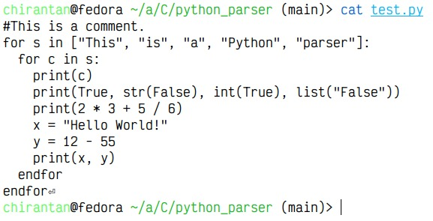

Tokens:
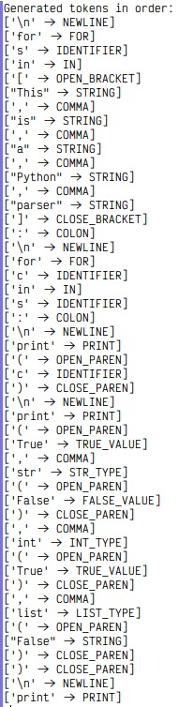
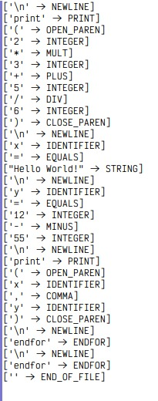
Symbol Table and Parsing:
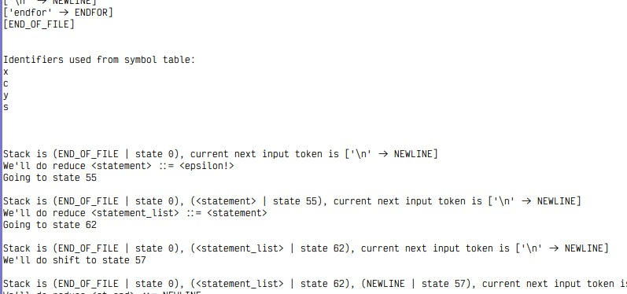
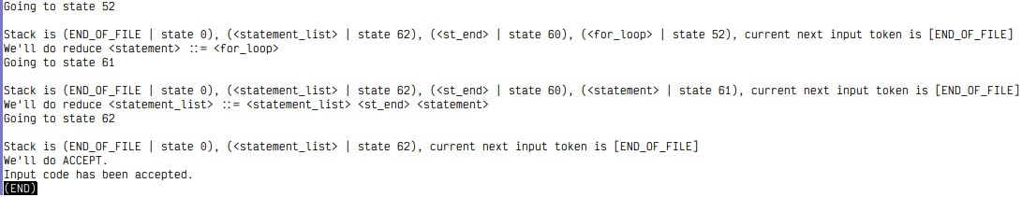

ACKNOWLEDGEMENT

We would like to express our heartfelt gratitude to Dr. Nandini Mukherjee, for her invaluable guidance, encouragement, and support throughout the duration of this project. Her profound knowledge and clear instruction in the domain of compiler design have played a pivotal role in the successful completion of this work.
This project, which encompasses the construction of a context-free grammar (CFG), development of a lexical analyzer, implementation of a symbol table, and design of a bottom-up parser for a simplified Python-like language, has significantly enhanced our understanding of the fundamental principles of programming language processing.
We are especially thankful for her continuous mentorship, timely feedback, and dedication, all of which have greatly contributed to the academic rigor and completeness of this project.

